

**COMSATS University Islamabad (CUI)**

Software Requirement Specification  
(SRS DOCUMENT)

for

**Smart Construction Manager**  
Version 1.0

***By***

**Talha Ejaz CIIT/SP18-BCS-161/ISB**

**Waleed Butt CIIT/SP18-BCS-170/ISB**

***Supervisor*Dr. Ashfaq Hussain Farooqi**

*Bachelor of Science in Computer Science (2018-2022)*

Revision History

|  |  |  |  |
| --- | --- | --- | --- |
| **Name** | **Date** | **Reason for Changes** | **Version** |
|  |  |  |  |
|  |  |  |  |
|  |  |  |  |
|  |  |  |  |
|  |  |  |  |
|  |  |  |  |

Application Evaluation History

|  |  |
| --- | --- |
| **Comments (by committee)**  **\*include the ones given at scope time both in doc and presentation** | **Action Taken** |
| ‘Modules are clear and Well defined. Can Proceed for next step’ – Dr Basit Raza | N/A |
| ‘Project idea is ok. All the modules are properly explained ‘– Mr. Zulfiqar Ali | N/A |
| ‘Add some major modules other than management systems’ – Tehseen Riaz Abbasi | Modules Added |
|  |  |

Supervised by

Dr. Ashfaq Hussain Farooqi

Signature______________

**Table of Contents**

Revision History i

Application Evaluation History ii

1. Introduction 1

1.1 Purpose 1

1.2 Scope and Modules 1

2. Overall Description 2

2.1 Product Perspective 2

2.2 Operating Environment 2

3. Design and Implementation Constraints 3

4. Requirement Identifying Technique 3

4.1 Use Case Diagram 3

4.2 Use Case Description 8

5. Functional Requirements 60

6. Non-Functional Requirements 106

6.1 Reliability 106

6.2 Usability 106

6.3 Performance 106

6.4 Security 106

7. External Interface Requirements 107

7.1 User Interfaces 107

7.2 Software Interfaces 109

7.3 Hardware Interfaces 109

7.4 Communication Interfaces 109

8. Project Gantt Chart 110

9. Conclusion 110

10. Appendices 110

11. References 110

12. Plagiarism Report 110

# 

# Introduction

This is the SRS (Software Requirement Specification) document for our project Smart Construction Manager. The document briefly explains the working and description of the project. The document contains the Use Cases against specified modules. The Functional and Non-Functional requirements are also elicited in the document. The UML diagrams and Class diagrams explain the flow of the application. Moreover, user interfaces describe the working of application for the end user.

## Purpose

Smart Construction Manager is a One Window Solution for the construction process of housing in the state. Keeping in view the incumbent government’s housing and construction policies & packages to minimize the time & effort for the construction process and ensure transparency. This solution also addresses unexpected turn of events in the fiscal policies caused by the global pandemic (COVID-19). It also ensures the safety of people regarding the SOPs. Smart Construction Manager is an all-rounder application addressing basic house construction needs.

## Scope and Modules

System will provide a one window application and act as agent of communication between construction companies, user, and government bodies. The user will provide the required information to the system the system will authenticate the user. User will submit request to respective organization (depending upon the location of project) & The construction company. The authorities and the industries will accept the request. Design and Layout will be sent by user. After review authorities and industries will generate the response.

### Modules

**First module** buys and sell, user can buy land and other construction equipment posted by other users for sale. User can search and chat with other users. **Second module**, Land Transfers and Ownerships will provide user the interface to manage the properties owned. **Third module** Land Grabbing deals with the issue of land grabbers. The **Fourth module** deals with approval requests to respective development authorities. **Fifth module** deals with user’s communication with government bodies for utility services. And **sixth module** will be for administrators of government bodies to manage user requests. **Seventh module** deals with the user designing map for the house. User will have 3d models to select from.

# Overall Description

The government organizations such as the development authorities of different cities have introduced the concepts of One-window operations to streamline the working process, our project is providing faster and easier access to this operation.

## Product Perspective

Smart Construction Manager is designed to ease the entire process of construction. The product is an alternate to growing market of construction site. Mostly websites like Zameen.com and Graana.com offer the buy and sell functionality. Smart Construction Manager will help user to communicate with government bodies too.

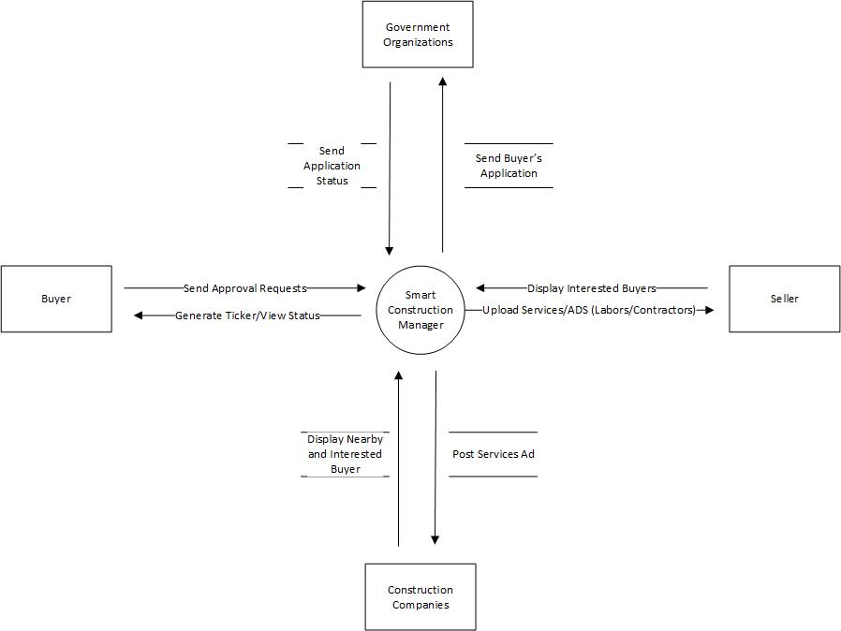

Figure 1: Context Diagram of Targeted Project

## Operating Environment

***OE-1:*** *The System shall operate correctly with the following web browsers: Firefox versions 80 through own wards; Google Chrome (all versions); and Apple Safari versions 10.0 and above.*

***OE-*2:** *The Minimum Smart Phone OS requirement is 6.0 for Android and IOS 9 for iPhones.*

***OE-3:*** *The Application will be available for Residence of Islamabad, Pakistan. In future, we will be upscaling to be used country wide.*

# Design and Implementation Constraints

*CO-1: The system shall use the current corporate standard MongoDB database engine*

*CO-2: The system shall use ExpressJS as Web Backend and ReactJS as Web Frontend Framework*

*CO-3: The system shall use React Native for Smart Phone Development (Android and IOS).*

# Requirement Identifying Technique

The requirements for the project will be gathered using Interviews and online Google Forms.

## Use Case Diagram

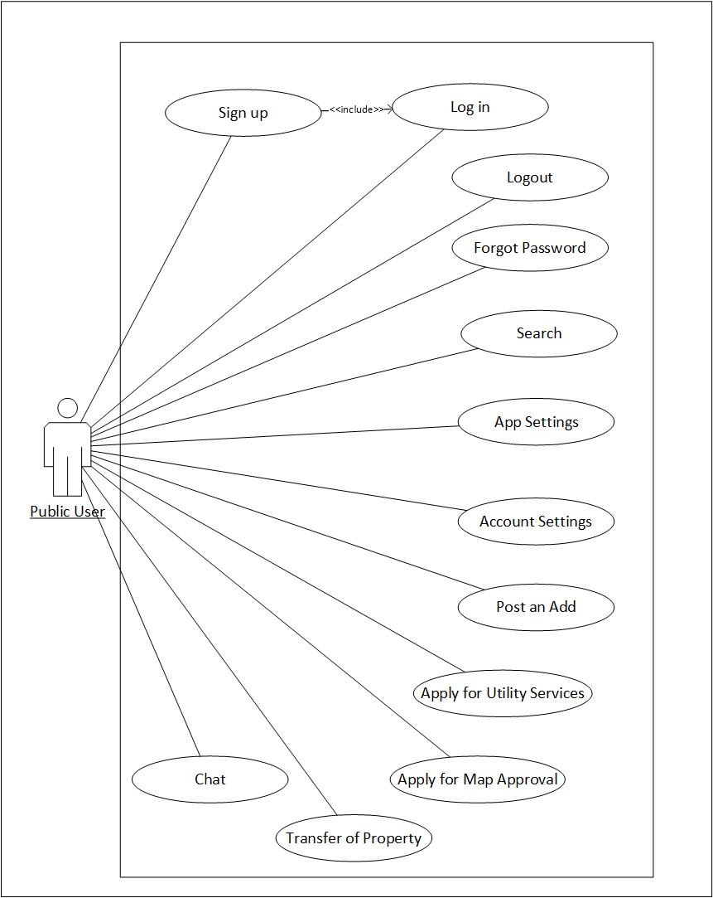

Figure 2: Use Case Diagram Showing Actions of User from Home Screen

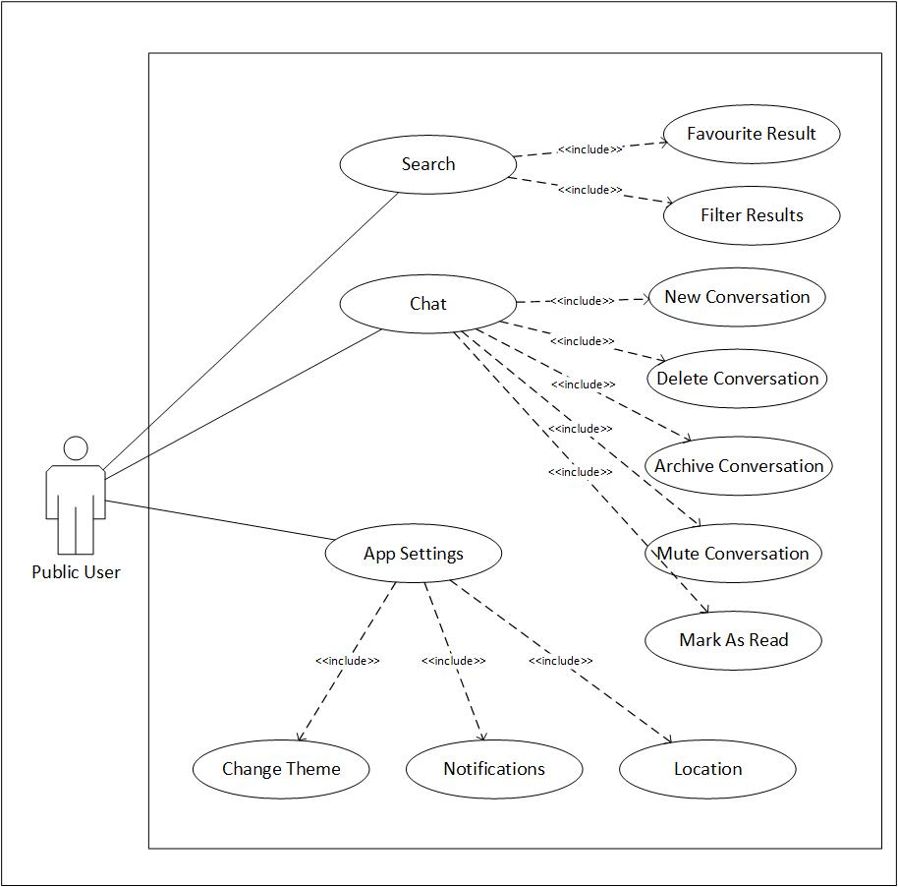

Figure 3: User Interface with Basic App Features

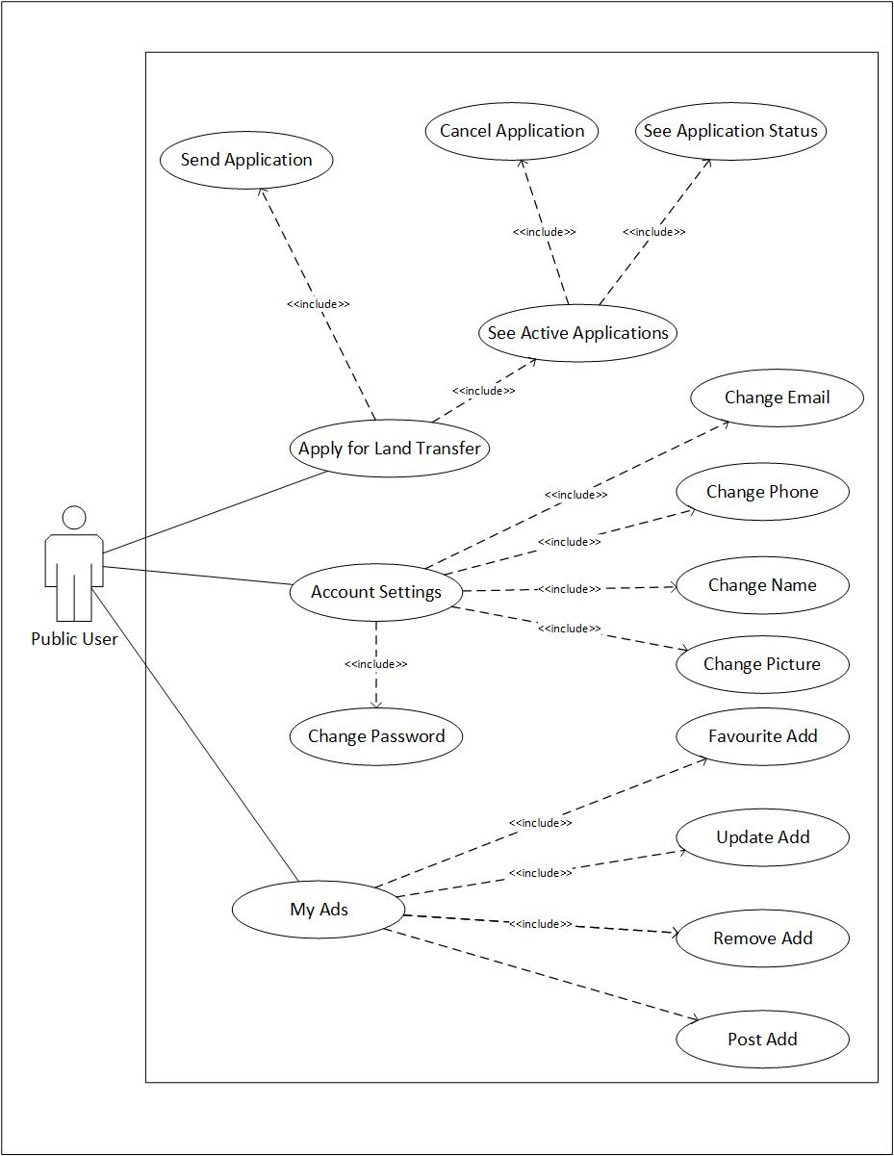

Figure 4: Use Case Diagram Explaining Activities of User

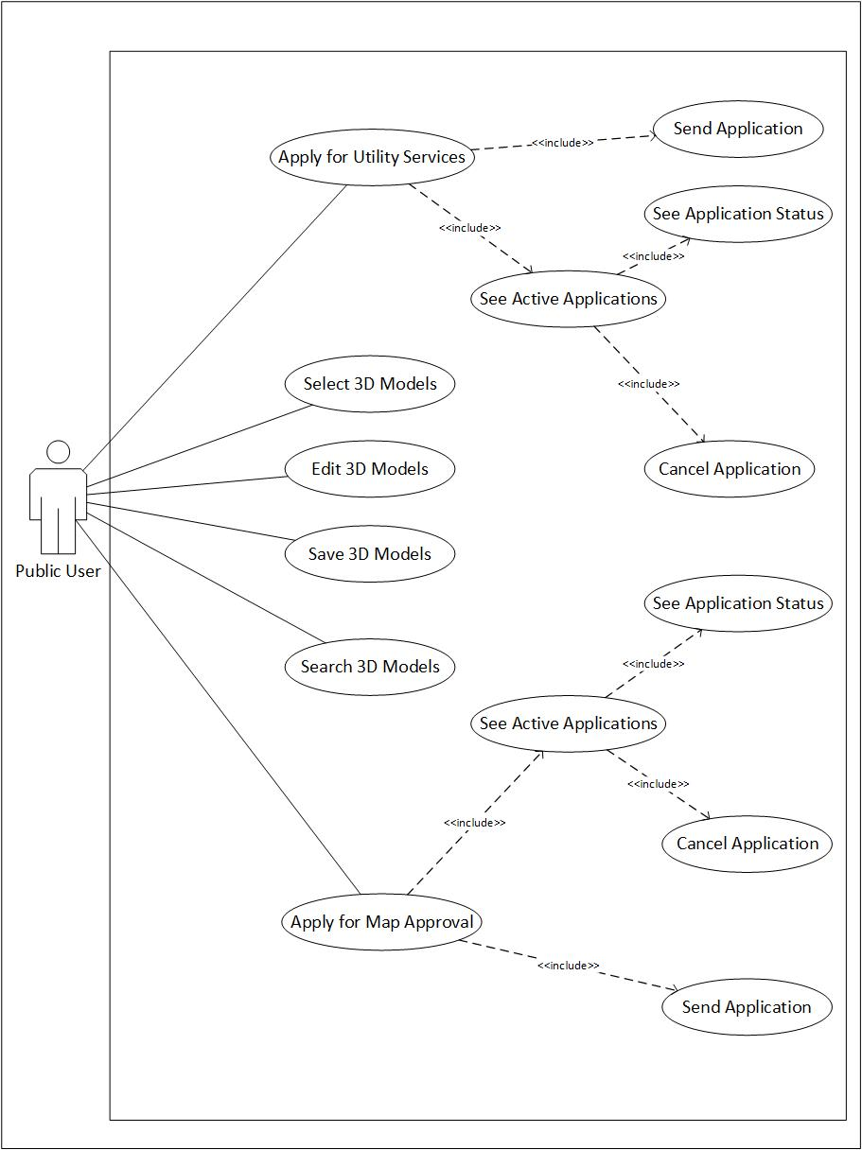

Figure 5: Use Case Diagram Showing Application Procedure with Official Authorities

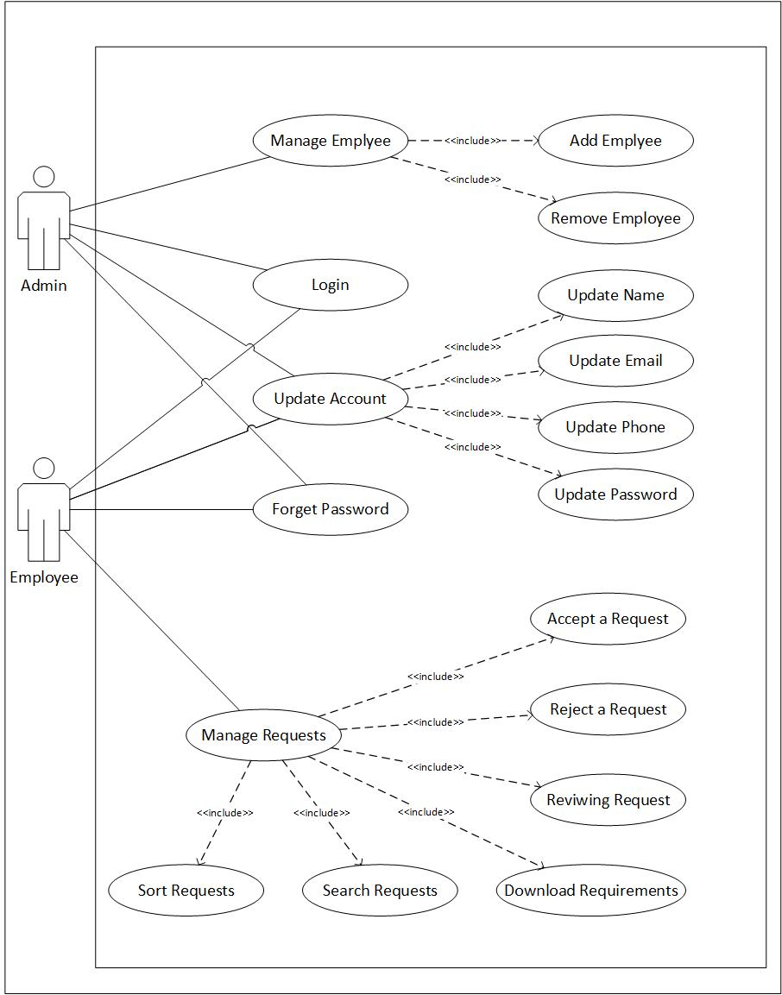

Figure 6: Use Case Diagram Explaining Activities of Admin

## Use Case Description

Following are the use cases for system Smart Construction Manager

### Module 1: Buy and Sell:

Following are the use cases for the module 1:

Table 1: Post ad use case.

|  |  |
| --- | --- |
| **Use Case ID:** | UC-1.1 |
| **Use Case Name:** | Post ad |
| **Actors:** | Primary Actor: User Secondary Actor: Smart Construction Manager |
| **Description:** | User will be able to post ad |
| **Trigger:** | Click on the “Post ad” button |
| **Level:** | Medium |
| **Preconditions:** | PRE-1. User has logged in the account. |
| **Includes:** | Use case 1.1, 1.2, 1.3 |
| **Normal Flow:** | 1. User will click on the post ad button 2. User will select the ad category 3. User will enter ad description 4. User will enter service price 5. User will enter service location 6. User will press ‘post’ button |
| **Alternative Flows:** | N/A |
| **Exceptions:** | 9a. if user doesn’t fill all the fields   1. Prompt message will appear “please enter all fields” |
| **Postconditions:** | POST-1. User will be able to post an ad |
| **Business Rules** | N/A |
| **Assumptions:** | User has an active internet connection.  User has installed the application.  User has an account. |

Table 2: Search ad use case.

|  |  |
| --- | --- |
| **Use Case ID:** | UC-1.2 |
| **Use Case Name:** | Search ad |
| **Actors:** | Primary Actor: User Secondary Actor: Smart Construction Manager |
| **Description:** | User will be able to Search an ad |
| **Trigger:** | Click on the “Search ad” button |
| **Level:** | Medium |
| **Preconditions:** | PRE-1. User has logged in the account. |
| **Includes:** | Use case 1.1, 1.2, 1.3 |
| **Normal Flow:** | 1. User will click on the search ad button. 2. User will type the commodity to search. 3. User will select the desired the search result. 4. User can filter through search result. |
| **Alternative Flows:** | N/A |
| **Exceptions:** | N/A |
| **Postconditions:** | POST-1. User will be able to search an ad |
| **Business Rules** | N/A |
| **Assumptions:** | User has an active internet connection.  User has installed the application.  User has an account. |

Table 3: View ad use case.

|  |  |
| --- | --- |
| **Use Case ID:** | UC-1.3 |
| **Use Case Name:** | View ad |
| **Actors:** | Primary Actor: User Secondary Actor: Smart Construction Manager |
| **Description:** | User will be able to View a posted ad |
| **Trigger:** | Click on the “View ad” button |
| **Level:** | Medium |
| **Preconditions:** | PRE-1. User has logged in the account. |
| **Includes:** | Use case 1.1, 1.2, 1.3 |
| **Normal Flow:** | 1. User will click on the view ad button 2. User will select the desired posted ad 3. User will click ok button |
| **Alternative Flows:** | N/A |
| **Exceptions:** | 2a if user doesn’t select the desired ad   1. Prompt message will appear “please select the desired ad” |
| **Postconditions:** | POST-1. User will be able to view a desired ad. |
| **Business Rules** | N/A |
| **Assumptions:** | User has an active internet connection.  User has installed the application.  User has an account. |

Table 4: Delete ad use case.

|  |  |
| --- | --- |
| **Use Case ID:** | UC-1.4 |
| **Use Case Name:** | Delete ad |
| **Actors:** | Primary Actor: User Secondary Actor: Smart Construction Manager |
| **Description:** | User will be able to Delete an ad |
| **Trigger:** | Click on the “Delete ad” button |
| **Level:** | Medium |
| **Preconditions:** | PRE-1. User has logged in the account. |
| **Includes:** | Use case 1.1, 1.2, 1.3 |
| **Normal Flow:** | 1. User will select my adds button 2. User will click on the delete ad button 3. User will select the desired posted ad 4. User will click ok button |
| **Alternative Flows:** | N/A |
| **Exceptions:** | 2a if user doesn’t select the desired ad   1. Prompt message will appear “please select the desired ad” |
| **Postconditions:** | POST-1. User will be able to delete an ad |
| **Business Rules** | N/A |
| **Assumptions:** | User has an active internet connection.  User has installed the application.  User has an account. |

Table 5: Edit ad use case.

|  |  |
| --- | --- |
| **Use Case ID:** | UC-1.5 |
| **Use Case Name:** | Edit ad |
| **Actors:** | Primary Actor: User Secondary Actor: Smart Construction Manager |
| **Description:** | User will be able to Edit an ad |
| **Trigger:** | Click on the “Edit ad” button |
| **Level:** | Medium |
| **Preconditions:** | PRE-1. User has logged in the account. |
| **Includes:** | Use case 1.1, 1.2, 1.3 |
| **Normal Flow:** | 1. User will select my adds button 2. User will click on the edit ad button 3. User will select the desired posted ad 4. User will click ok button |
| **Alternative Flows:** | N/A |
| **Exceptions:** | 2a if user doesn’t select the desired ad   1. Prompt message will appear “please select the desired ad” |
| **Postconditions:** | POST-1. User will be able to delete an ad |
| **Business Rules** | N/A |
| **Assumptions:** | User has an active internet connection.  User has installed the application.  User has an account. |

Table 6: Reviews use case.

|  |  |
| --- | --- |
| **Use Case ID:** | UC-1.6 |
| **Use Case Name:** | Reviews |
| **Actors:** | Primary Actor: User Secondary Actor: Smart Construction Manager |
| **Description:** | User will be able to write a review |
| **Trigger:** | Click on the Review button |
| **Level:** | Medium |
| **Preconditions:** | PRE-1. User has logged in the account. |
| **Includes:** | Use case 1.1, 1.2, 1.3 |
| **Normal Flow:** | 1. User will visit an account 2. User will click on the “review” button 3. User will type a review 4. User will press post button. |
| **Alternative Flows:** | N/A |
| **Exceptions:** | 4a. if user doesn’t type anything   1. Prompt message will appear “please write something” |
| **Postconditions:** | POST-1. User will be able to chat with other accounts |
| **Business Rules** | N/A |
| **Assumptions:** | User has an active internet connection.  User has installed the application.  User has an account. |

Table 7: Send Message use case.

|  |  |
| --- | --- |
| **Use Case ID:** | UC-1.7 |
| **Use Case Name:** | Send Message |
| **Actors:** | Primary Actor: User Secondary Actor: Smart Construction Manager |
| **Description:** | User will be able to send a message |
| **Trigger:** | Click on the Conversation |
| **Level:** | High |
| **Preconditions:** | PRE-1. User has logged in the account. |
| **Includes:** | Use case 1.1, 1.2, 1.3 |
| **Normal Flow:** | 1. User will click conversation button 2. User will select conversation 3. User may select new conversation 4. User will type receiver’s username 5. User will enter text in text field, record audio, attach image or attach video. 6. User will press send to send message. |
| **Alternative Flows:** | N/A |
| **Exceptions:** | 4a. if user doesn’t type anything   1. Prompt message will appear “please write something” |
| **Postconditions:** | POST-1. User will receive confirmation on message delivery |
| **Business Rules** | N/A |
| **Assumptions:** | User has an active internet connection.  User has installed the application.  User has an account. |

Table 8: Receive Message use case.

|  |  |
| --- | --- |
| **Use Case ID:** | UC-1.8 |
| **Use Case Name:** | Receive Message |
| **Actors:** | Primary Actor: User Secondary Actor: Smart Construction Manager |
| **Description:** | User will be able to read the received message |
| **Trigger:** | Click on the Conversation/Notification |
| **Level:** | High |
| **Preconditions:** | PRE-1. User has logged in the account. |
| **Includes:** | Use case 1.1, 1.2, 1.3 |
| **Normal Flow:** | 1. User will receive notification on message arrival 2. User will click conversation button 3. User will select conversation 4. User will read the message |
| **Alternative Flows:** | 1. User will receive notification on message arrival. 2. User will click notification from notification panel. 3. User will read the message |
| **Exceptions:** | 4a. if user is not connected to the internet user will not receive messages.   1. Prompt message will appear “please connect to internet to chat” |
| **Postconditions:** | POST-1. User will receive confirmation on message delivery |
| **Business Rules** | N/A |
| **Assumptions:** | User has an active internet connection.  User has installed the application.  User has an account. |

Table 9: Delete Message use case.

|  |  |
| --- | --- |
| **Use Case ID:** | UC-1.9 |
| **Use Case Name:** | Delete Message |
| **Actors:** | Primary Actor: User Secondary Actor: Smart Construction Manager |
| **Description:** | User will be able to delete sent message |
| **Trigger:** | Press and hold the message in chat |
| **Level:** | High |
| **Preconditions:** | PRE-1. User has logged in the account. |
| **Includes:** | Use case 1.1, 1.2, 1.3 |
| **Normal Flow:** | 1. User will open conversation 2. User will press and hold the message 3. User will select delete message from the popup |
| **Alternative Flows:** | N/A |
| **Exceptions:** | 4a. if user is not connected to the internet user will not delete messages.   1. Prompt message will appear “please connect to internet to chat” |
| **Postconditions:** | POST-1. Message will be deleted from user’s conversation only |
| **Business Rules** | N/A |
| **Assumptions:** | User has an active internet connection.  User has installed the application.  User has an account. |

Table 10: Delete Message for everyone use case.

|  |  |
| --- | --- |
| **Use Case ID:** | UC-1.10 |
| **Use Case Name:** | Delete Message for Everyone |
| **Actors:** | Primary Actor: User Secondary Actor: Smart Construction Manager |
| **Description:** | User will be able to delete sent message from another user’s chat |
| **Trigger:** | Press and hold the message in chat |
| **Level:** | High |
| **Preconditions:** | PRE-1. User has sent a message  PRE-2. Message was sent only 1 hour ago. |
| **Includes:** | Use case 1.1, 1.2, 1.3 |
| **Normal Flow:** | 1. User will open conversation 2. User will press and hold the message 3. Popup will appear 4. User will select delete message for all from the popup |
| **Alternative Flows:** | N/A |
| **Exceptions:** | 4a. if user is not connected to the internet user will not delete messages.   1. Prompt message will appear “please connect to internet to chat” |
| **Postconditions:** | POST-1. Message will be deleted from user’s conversation.  POST-2. Message will be deleted from receiver’s conversation. |
| **Business Rules** | N/A |
| **Assumptions:** | User has an active internet connection.  User has installed the application.  User has an account. |

### Module 2: Land Transfers and Ownerships:

Following are the use cases for module 2

Table 11: Sign up for web use case.

|  |  |
| --- | --- |
| **Use Case ID:** | UC-2.1 |
| **Use Case Name:** | Sign up for web |
| **Actors:** | Primary Actor: User Secondary Actor: Smart Construction Manager |
| **Description:** | The user will be able to sign up and use the application |
| **Trigger:** | Click the “sign up” button |
| **Level:** | Enter Use Case Goal Level here: High |
| **Preconditions:** | PRE-1. User has accessed the Web page  PRE-2. Valid username & password  PRE-3. Valid Email Address & cell number |
| **Includes:** | N/A |
| **Normal Flow:** | 1. User clicks on the “sign up” link 2. User will enter first & last Name 3. User will enter valid email address 4. User will enter valid cell number 5. User will set password 6. User will confirm password 7. Agree to terms and condition 8. See terms and condition. 9. User will click on “sign up” button |
| **Alternative Flows:**  **[Alternative Flow 1 – Not in Network]** | N/A |
| **Exceptions:** | 1a. If user doesn’t enter valid email address   1. Prompt message will be shown “Please enter valid email address”   5a. If user doesn’t enter valid cell number   1. Prompt message will be shown “Please enter valid cell number”   6a. If user enters different password than in step 6 of normal flow   1. Prompt message will be shown “Please enter same password”   7a. If user doesn’t fill the required fields   1. Prompt message will appear “Please enter all fields” |
| **Postconditions:** | POST-1. Application will display message “Account Successfully Registered”  POST-2. User will be signed in to the account. |
| **Business Rules** | N/A |
| **Assumptions:** | User has an active internet connection.  User has accessed the webpage. |

Table 12: Sign up for mobile use case.

|  |  |
| --- | --- |
| **Use Case ID:** | UC-2.2 |
| **Use Case Name:** | Sign up for mobile |
| **Actors:** | Primary Actor: User Secondary Actor: Smart Construction Manager |
| **Description:** | The user will be able to sign up and use the application |
| **Trigger:** | Tap the “sign up” button |
| **Level:** | Enter Use Case Goal Level here: High |
| **Preconditions:** | PRE-1. User has installed the application  PRE-2. Valid username & password  PRE-3. Valid Email Address & cell number |
| **Includes:** | N/A |
| **Normal Flow:** | 1. User clicks on the “sign up” button 2. User will enter first & last Name 3. User will enter valid email address 4. User will enter valid cell number 5. User will set password 6. User will confirm password 7. Agree to terms and condition 8. See terms and condition. 9. User will click on “sign up” button |
| **Alternative Flows:**  **[Alternative Flow 1 – Not in Network]** | N/A |
| **Exceptions:** | 1a. If user doesn’t enter valid email address   1. Prompt message will be shown “Please enter valid email address”   5a. If user doesn’t enter valid cell number   1. Prompt message will be shown “Please enter valid cell number”   7a. If user enters different password than in step 6 of normal flow   1. Prompt message will be shown “Please enter same password”   8a. If user doesn’t fill the required fields   1. Prompt message will appear “Please enter all fields” |
| **Postconditions:** | POST-1. Application will display message “Account Successfully Registered”  POST-2. User will be signed in to the account. |
| **Business Rules** | N/A |
| **Assumptions:** | User has an active internet connection.  User has installed the application |

Table 13: Login use case.

|  |  |
| --- | --- |
| **Use Case ID:** | UC-2.3 |
| **Use Case Name:** | Login |
| **Actors:** | Primary Actor: User Secondary Actor: Smart Construction Manager |
| **Description:** | The user will be able to login and use the application |
| **Trigger:** | Click the “Login” button |
| **Level:** | Enter Use Case Goal Level here: High |
| **Preconditions:** | PRE-1. User has accessed the Login page |
| **Includes:** | UC-1.1, UC-1.2 |
| **Normal Flow:** | 1. User clicks on the “Login” button 2. User will enter valid email address 3. User will enter password 4. User will click on “Login” button |
| **Alternative Flows:**  **[Alternative Flow 1 – Not in Network]** | N/A |
| **Exceptions:** | 4a If user enters any wrong field   1. Prompt message will appear “Please enter username and password again” |
| **Postconditions:** | POST-1. User will be able to login the account |
| **Business Rules** | N/A |
| **Assumptions:** | User has an active internet connection.  User has installed the application.  User has an account |

Table 14: Forgot password use case.

|  |  |
| --- | --- |
| **Use Case ID:** | UC-2.4 |
| **Use Case Name:** | Forgot Password |
| **Actors:** | Primary Actor: User Secondary Actor: Smart Construction Manager |
| **Description:** | The user will be able to retrieve account in case of forgetting the password. |
| **Trigger:** | Click the “Forget Password” button |
| **Level:** | Enter Use Case Goal Level here: medium |
| **Preconditions:** | PRE-1. User has accessed the forget password webpage |
| **Includes:** | Use case 1.1, use case 1.2 use case |
| **Normal Flow:** | 1. User clicks on the “forget password” button 2. User will enter valid email address 3. User will be sent a code on email 4. User will type the code 5. User will change the password |
| **Alternative Flows:** | N/A |
| **Exceptions:** | 2a If user enters invalid email   1. Prompt message will appear “Please enter valid email address” |
| **Postconditions:** | POST-1. User will be able to reset the password |
| **Business Rules** | N/A |
| **Assumptions:** | User has an active internet connection.  User has installed the application.  User has an account. |

Table 15: Apply for transfer use case.

|  |  |
| --- | --- |
| **Use Case ID:** | UC-2.5 |
| **Use Case Name:** | Apply for transfer |
| **Actors:** | Primary Actor: User Secondary Actor: Smart Construction Manager, Development Authority |
| **Description:** | The user will be able to apply for transfer of ownership of land |
| **Trigger:** | Click on the “Apply for Transfer” button |
| **Level:** | Enter Use Case Goal Level here: medium |
| **Preconditions:** | PRE-1. User has logged in the account. |
| **Includes:** | Use case 1.1, use case 1.2 use case 1.3 |
| **Normal Flow:** | 1. User will click the apply for transfer button 2. A new form will appear for the transfer letter 3. User will enter his full Name 4. User will enter CNIC 5. A ticket will be generated for the user to submit required document through the one window operation. |
| **Alternative Flows:** | N/A |
| **Exceptions:** | 4a If user enters invalid CNIC   1. Prompt message will appear “Please enter valid CNIC number” |
| **Postconditions:** | POST-1. User will be able to apply for Transfer. |
| **Business Rules** | BR-1 Application time will be 9-5pm |
| **Assumptions:** | User has an active internet connection.  User has installed the application.  User has an account.  User has a CNIC. |

Table 16: Receive NDC use case.

|  |  |
| --- | --- |
| **Use Case ID:** | UC-2.6 |
| **Use Case Name:** | Receive NDC (No Demand Certificate) |
| **Actors:** | Primary Actor: User Secondary Actor: Smart Construction Manager, Development Authority |
| **Description:** | The user will be able to receive the NDC after reviewal by the development authority |
| **Trigger:** | Click on the “Receive NDC” button |
| **Level:** | Enter Use Case Goal Level here: medium |
| **Preconditions:** | PRE-1. User has logged in the account.  PRE-2. User has submitted the transfer letter |
| **Includes:** | Use case 1.1, 1.2, 1.3, 1.5 |
| **Normal Flow:** | 1. User will click on active transfer button to see NDC response status |
| **Alternative Flows:** | N/A |
| **Exceptions:** | N/A |
| **Postconditions:** | POST-1. User will be able to view NDC. |
| **Business Rules** | N/A |
| **Assumptions:** | User has an active internet connection.  User has installed the application.  User has an account. |

Table 17: Submit NDC use case.

|  |  |
| --- | --- |
| **Use Case ID:** | UC-2.7 |
| **Use Case Name:** | Submit NDC (No Demand Certificate) |
| **Actors:** | Primary Actor: User Secondary Actor: Smart Construction Manager, Development Authority |
| **Description:** | The user will be able to submit the NDC after reviewal by the development authority |
| **Trigger:** | Click on the “Submit NDC” button |
| **Level:** | Enter Use Case Goal Level here: medium |
| **Preconditions:** | PRE-1. User has logged in the account.  PRE-2. User has submitted the transfer letter  PRE-2. User has received NDC |
| **Includes:** | Use case 1.1, 1.2, 1.3, 1.5, 1.6 |
| **Normal Flow:** | 1. User will click on the Submit NDC button 2. User will enter tax statement for the previous fiscal year 3. User will click on submit button. |
| **Alternative Flows:** | N/A |
| **Exceptions:** | 3a. If user enters wrong CNIC   1. Prompt message will be displayed “please enter CNIC again”   6a. If any field is not filled   1. Prompt message will be displayed “please enter all fields” |
| **Postconditions:** | POST-1. User will be able to submit NDC. |
| **Business Rules** | N/A |
| **Assumptions:** | User has an active internet connection.  User has installed the application.  User has an account.  User has received NDC. |

Table 18: Meeting Officials use case.

|  |  |
| --- | --- |
| **Use Case ID:** | UC-2.8 |
| **Use Case Name:** | Meeting officials |
| **Actors:** | Primary Actor: User Secondary Actor: Smart Construction Manager, Development Authority |
| **Description:** | After submission of NDC, the officials will set up a meeting with the applicant (user) |
| **Trigger:** | Click on the “Schedule Meeting” button |
| **Level:** | Enter Use Case Goal Level here: medium |
| **Preconditions:** | PRE-1. User has logged in the account.  PRE-2. User has submitted the transfer letter  PRE-3. User has submitted NDC |
| **Includes:** | Use case 1.1, 1.2, 1.3, 1.5, 1.6, 1.7 |
| **Normal Flow:** | 1. User will click on the “set meeting” button 2. User will enter full Name 3. User will enter CNIC 4. User will select the date to schedule meeting 5. User will select time to schedule meeting |
| **Alternative Flows:** | N/A |
| **Exceptions:** | 3a. If user enters wrong CNIC   1. Prompt message will be displayed “please enter CNIC again”   4a. If user enters a non-working day   1. Prompt message will be displayed “please select a working day”   5a. If user enters after work hours   1. Prompt message will be displayed “please select working hours” |
| **Postconditions:** | POST-1. User will be able to schedule meeting with development authority |
| **Business Rules** | BR-1 meeting can take place only in working day and hours |
| **Assumptions:** | User has an active internet connection.  User has installed the application.  User has an account.  User has submitted the NDC. |

Table 19: View Active Transfers use case.

|  |  |
| --- | --- |
| **Use Case ID:** | UC-2.9 |
| **Use Case Name:** | View Active Transfers |
| **Actors:** | Primary Actor: User Secondary Actor: Smart Construction Manager, Development Authority |
| **Description:** | After submission of NDC, user can view the status of transfers. |
| **Trigger:** | Click on the “View Active Transfers” button |
| **Level:** | Enter Use Case Goal Level here: medium |
| **Preconditions:** | PRE-1. User has logged in the account.  PRE-2. User has submitted the transfer letter |
| **Includes:** | Use case 1.1, 1.2, 1.3, 1.5, 1.6, 1.7 |
| **Normal Flow:** | 1. User will click on view active transfers button 2. User will click on the desired transfer |
| **Alternative Flows:** | N/A |
| **Exceptions:** | N/A |
| **Postconditions:** | POST-1. User will be able to view the desired transfer |
| **Business Rules** | N/A |
| **Assumptions:** | User has an active internet connection.  User has installed the application.  User has an account.  User has submitted the NDC. |

Table 20: Cancel Active Transfers use case.

|  |  |
| --- | --- |
| **Use Case ID:** | UC-2.10 |
| **Use Case Name:** | Cancel Active Transfers |
| **Actors:** | Primary Actor: User Secondary Actor: Smart Construction Manager, Development Authority |
| **Description:** | User will be able to cancel any active transfer |
| **Trigger:** | Click on the “Cancel Active Transfers” button |
| **Level:** | Medium |
| **Preconditions:** | PRE-1. User has logged in the account.  PRE-2. User has submitted the transfer letter |
| **Includes:** | Use case 1.1, 1.2, 1.3, 1.5, 1.6, 1.7,1.9 |
| **Normal Flow:** | 1. User will click on cancel active transfers button 2. User will click on the desired active transfer 3. User will click ok. |
| **Alternative Flows:** | N/A |
| **Exceptions:** | N/A |
| **Postconditions:** | POST-1. User will be able to cancel the desired active transfer |
| **Business Rules** | N/A |
| **Assumptions:** | User has an active internet connection.  User has installed the application.  User has an account.  User has submitted the NDC. |

Table 21: Update Active Transfers use case.

|  |  |
| --- | --- |
| **Use Case ID:** | UC-2.11 |
| **Use Case Name:** | See Active Transfer Status |
| **Actors:** | Primary Actor: User Secondary Actor: Smart Construction Manager, Development Authority |
| **Description:** | User will be able to see the status of any active transfer |
| **Trigger:** | Click on the Transfer Requests from Active Transfers List. |
| **Level:** | Medium |
| **Preconditions:** | PRE-1. User has logged in the account.  PRE-2. User has submitted the transfer letter |
| **Includes:** | Use case 1.1, 1.2, 1.3, 1.5, 1.6, 1.7,1.9 |
| **Normal Flow:** | 1. User will click on update active transfers button 2. User will click on the desired active transfer 3. User will change the details. 4. User will click ok. |
| **Alternative Flows:** | N/A |
| **Exceptions:** | N/A |
| **Postconditions:** | POST-1. User will be able to update the active transfer. |
| **Business Rules** | N/A |
| **Assumptions:** | User has an active internet connection.  User has installed the application.  User has an account.  User has submitted the NDC. |

### Module 3: Land Grabbers

Following are the tabular use cases for module 3.

Table 22: Apply for land grabbing use case.

|  |  |
| --- | --- |
| **Use Case ID:** | UC-3.1 |
| **Use Case Name:** | Apply for Grabbing Case |
| **Actors:** | Primary Actor: User Secondary Actor: Smart Construction Manager, Development Authority |
| **Description:** | User will be able to apply for land grabbing issue. |
| **Trigger:** | Click on the “Apply for land possession” button |
| **Level:** | Medium |
| **Preconditions:** | PRE-1. User has logged in the account.  PRE-2. User has submitted the transfer letter  PRE-2. User has submitted the NDC |
| **Includes:** | Use case 1.1, 1.2, 1.3, 1.5, 1.6, 1.7,1.9 |
| **Normal Flow:** | 1. User will click on the apply for land grabbing button 2. User will be directed to the requirement form 3. User will click on submit. |
| **Alternative Flows:** | N/A |
| **Exceptions:** | 4a. if user doesn’t fill any details   1. Message will be prompted ‘please enter the details again’ |
| **Postconditions:** | POST-1. Ticket will be generated for land possession application. |
| **Business Rules** | BR-1 user can apply only in working hours i.e. 9-5pm |
| **Assumptions:** | User has an active internet connection.  User has installed the application.  User has an account.  User has submitted the NDC. |

Table 23: View Active Applications use case.

|  |  |
| --- | --- |
| **Use Case ID:** | UC-3.2 |
| **Use Case Name:** | View Active Application |
| **Actors:** | Primary Actor: User Secondary Actor: Smart Construction Manager, Development Authority |
| **Description:** | After applying for Land Grabbing case. User can see active applications. |
| **Trigger:** | Click on the “View Active Application” button |
| **Level:** | Enter Use Case Goal Level here: medium |
| **Preconditions:** | PRE-1. User has logged in the account.  PRE-2. User has submitted the Application for land grabbing |
| **Includes:** | Use case 1.1, 1.2, 1.3, 1.5, 1.6, 1.7 |
| **Normal Flow:** | 1. User will click on view active Application button 2. User will click on the desired application |
| **Alternative Flows:** | N/A |
| **Exceptions:** | N/A |
| **Postconditions:** | POST-1. User will be able to view the desired application |
| **Business Rules** | N/A |
| **Assumptions:** | User has applied for land grabbing application. |

Table 24: Cancel Active Application use case.

|  |  |
| --- | --- |
| **Use Case ID:** | UC-3.3 |
| **Use Case Name:** | Cancel Active Application |
| **Actors:** | Primary Actor: User Secondary Actor: Smart Construction Manager, Development Authority |
| **Description:** | User will be able to cancel any active Application |
| **Trigger:** | Click on the “Cancel Active Application” button |
| **Level:** | Medium |
| **Preconditions:** | PRE-1. User has logged in the account. |
| **Includes:** | Use case 1.1, 1.2, 1.3, 1.5, 1.6, 1.7,1.9 |
| **Normal Flow:** | 1. User will click on cancel active Application button 2. User will click on the desired active transfer 3. User will click ok. |
| **Alternative Flows:** | N/A |
| **Exceptions:** | N/A |
| **Postconditions:** | POST-1. User will be able to cancel the desired active transfer |
| **Business Rules** | N/A |
| **Assumptions:** | User has an active internet connection.  User has installed the application.  User has an account.  User has submitted the NDC. |

Table 25: Update Active Transfers use case.

|  |  |
| --- | --- |
| **Use Case ID:** | UC-3.4 |
| **Use Case Name:** | See Active Application Status |
| **Actors:** | Primary Actor: User Secondary Actor: Smart Construction Manager, Development Authority |
| **Description:** | User will be able to see the status of any active transfer |
| **Trigger:** | Click on the Application from Active Applications List. |
| **Level:** | Medium |
| **Preconditions:** | PRE-1. User has logged in the account.  PRE-2. User has submitted the transfer letter |
| **Includes:** | Use case 1.1, 1.2, 1.3, 1.5, 1.6, 1.7,1.9 |
| **Normal Flow:** | 1. User will click on active application 2. See the status detail. |
| **Alternative Flows:** | N/A |
| **Exceptions:** | N/A |
| **Postconditions:** | POST-1. User will be able to update the active transfer. |
| **Business Rules** | N/A |
| **Assumptions:** | User has an active internet connection.  User has installed the application.  User has an account.  User has submitted the NDC. |

### Module 4: Land Approval:

Following are the tabular use cases for module 4:

Table 26: Apply for land Possession use case.

|  |  |
| --- | --- |
| **Use Case ID:** | UC-4.1 |
| **Use Case Name:** | Apply for Possession |
| **Actors:** | Primary Actor: User Secondary Actor: Smart Construction Manager, Development Authority |
| **Description:** | User will be able to apply for land possession |
| **Trigger:** | Click on the “Apply for land possession” button |
| **Level:** | Medium |
| **Preconditions:** | PRE-1. User has logged in the account.  PRE-2. User has submitted the transfer letter  PRE-2. User has submitted the NDC |
| **Includes:** | Use case 1.1, 1.2, 1.3, 1.5, 1.6, 1.7,1.9 |
| **Normal Flow:** | 1. User will click on the apply for land possession button 2. User will be directed to the land possession form 3. User will click on submit. |
| **Alternative Flows:** | N/A |
| **Exceptions:** | 4a. if user doesn’t fill any details   1. Message will be prompted ‘please enter the details again’ |
| **Postconditions:** | POST-1. Ticket will be generated for land possession application. |
| **Business Rules** | BR-1 user can apply only in working hours i.e. 9-5pm |
| **Assumptions:** | User has an active internet connection.  User has installed the application.  User has an account.  User has submitted the NDC. |

Table 27: Response of land Possession use case.

|  |  |
| --- | --- |
| **Use Case ID:** | UC-4.2 |
| **Use Case Name:** | View Possession Status |
| **Actors:** | Primary Actor: User Secondary Actor: Smart Construction Manager, Development Authority |
| **Description:** | User will be able to view possession status |
| **Trigger:** | Click on the possession from active possession list |
| **Level:** | Medium |
| **Preconditions:** | PRE-1. User has logged in the account.  PRE-2. User has submitted the transfer letter  PRE-3. User has submitted the NDC  PRE-4 User has applied for land possession |
| **Includes:** | Use case 1.1, 1.2, 1.3, 1.5, 1.6, 1.7,1.9, 2.1 |
| **Normal Flow:** | 1. User will click on possession from possession lists. |
| **Alternative Flows:** | N/A |
| **Exceptions:** | N/A |
| **Postconditions:** | POST-1. User will be able to check the approval status |
| **Business Rules** | N/A |
| **Assumptions:** | User has an active internet connection.  User has installed the application.  User has an account.  User has submitted the NDC.  User has applied for land possession |

Table 28: Use case to cancel possession application

|  |  |
| --- | --- |
| **Use Case ID:** | UC-4.3 |
| **Use Case Name:** | Cancel Possession Status |
| **Actors:** | Primary Actor: User Secondary Actor: Smart Construction Manager, Development Authority |
| **Description:** | User will be able to view possession status |
| **Trigger:** | Click on cross button on the possession from active possession list |
| **Level:** | Medium |
| **Preconditions:** | PRE-1. User has logged in the account.  PRE-2. User has submitted the transfer letter  PRE-3. User has submitted the NDC  PRE-4 User has applied for land possession |
| **Includes:** | Use case 1.1, 1.2, 1.3, 1.5, 1.6, 1.7,1.9, 2.1 |
| **Normal Flow:** | 1. User will click on cross button on the possession from possession lists. |
| **Alternative Flows:** | N/A |
| **Exceptions:** | N/A |
| **Postconditions:** | POST-1. User will be able to check the approval status |
| **Business Rules** | N/A |
| **Assumptions:** | User has an active internet connection.  User has installed the application.  User has an account.  User has submitted the NDC.  User has applied for land possession |

Table 29: Apply for map approval use case.

|  |  |
| --- | --- |
| **Use Case ID:** | UC-4.4 |
| **Use Case Name:** | Apply for map approval |
| **Actors:** | Primary Actor: User Secondary Actor: Smart Construction Manager, Development Authority |
| **Description:** | User will be able to apply for map approval |
| **Trigger:** | Click on the “Apply for map approval” button |
| **Level:** | Medium |
| **Preconditions:** | PRE-1. User has logged in the account.  PRE-2. User has submitted the transfer letter  PRE-3. User has submitted the NDC  PRE-4 User has received land possession |
| **Includes:** | Use case 1.1, 1.2, 1.3, 1.5, 1.6, 1.7,1.9, 2.1, 2.2, 2.3 |
| **Normal Flow:** | 1. User will click on the “Apply for map approval” button 2. User will attach proposed map. 3. User will click on submit |
| **Alternative Flows:** | N/A |
| **Exceptions:** | N/A |
| **Postconditions:** | POST-1. Ticket will be generated for map approval application. |
| **Business Rules** | BR-1 user can apply only in working hours i.e. 9-5pm |
| **Assumptions:** | User has an active internet connection.  User has installed the application.  User has an account.  User has submitted the NDC.  User has received for land possession |

Table 30: view active transfers use case.

|  |  |
| --- | --- |
| **Use Case ID:** | UC-4.5 |
| **Use Case Name:** | View active Applications |
| **Actors:** | Primary Actor: User Secondary Actor: Smart Construction Manager, Development Authority |
| **Description:** | User will be able to view active transfers |
| **Trigger:** | Click on the “view active Applications” button |
| **Level:** | Medium |
| **Preconditions:** | PRE-1. User has logged in the account.  PRE-2. User has submitted the transfer letter  PRE-3. User has submitted the NDC  PRE-4 User has received land possession |
| **Includes:** | Use case 1.1, 1.2, 1.3, 1.5, 1.6, 1.7,1.9, 2.1, 2.2, 2.3 |
| **Normal Flow:** | 1. User will click on the “view active Applications” button 2. User will select the desired transfer 3. User will press ok button |
| **Alternative Flows:** | N/A |
| **Exceptions:** | 2a if user doesn’t select the active transfer  Prompt message will appear” please select the desired transfer” |
| **Postconditions:** | POST-1. User will be able to view active transfers. |
| **Business Rules** | N/A |
| **Assumptions:** | User has an active internet connection.  User has installed the application.  User has an account.  User has submitted the NDC.  User has received for land possession  User has applied for transfer |

Table 31: Cancel active transfer use case.

|  |  |
| --- | --- |
| **Use Case ID:** | UC-4.6 |
| **Use Case Name:** | Cancel Approval Request |
| **Actors:** | Primary Actor: User Secondary Actor: Smart Construction Manager, Development Authority |
| **Description:** | User will be able to cancel active transfer |
| **Trigger:** | Click on the “cancel Approval Request” button |
| **Level:** | Medium |
| **Preconditions:** | PRE-1. User has logged in the account.  PRE-2. User has submitted the transfer letter  PRE-3. User has submitted the NDC  PRE-4 User has received land possession  PRE-5 User has an ongoing active transfer |
| **Includes:** | Use case 1.1, 1.2, 1.3, 1.5, 1.6, 1.7,1.9, 2.1, 2.2 |
| **Normal Flow:** | 1. User will click on the “Cancel Approval Request” button 2. User will select the desired transfer 3. User will press ok button |
| **Alternative Flows:** | N/A |
| **Exceptions:** | 2a if user doesn’t select the active transfer   1. Prompt message will appear” please select the desired transfer” |
| **Postconditions:** | POST-1. User will be able to cancel an active transfer |
| **Business Rules** | N/A |
| **Assumptions:** | User has an active internet connection.  User has installed the application.  User has an account.  User has submitted the NDC.  User has received for land possession  User has applied for transfer |

Table 32: View active transfer use case.

|  |  |
| --- | --- |
| **Use Case ID:** | UC-4.7 |
| **Use Case Name:** | View active request Status |
| **Actors:** | Primary Actor: User Secondary Actor: Smart Construction Manager, Development Authority |
| **Description:** | User will be able to view active request status |
| **Trigger:** | Click on the “Update active transfer” button |
| **Level:** | Medium |
| **Preconditions:** | PRE-1. User has logged in the account.  PRE-2. User has submitted the transfer letter  PRE-3. User has submitted the NDC  PRE-4 User has received land possession  PRE-5 User has an ongoing active transfer |
| **Includes:** | Use case 1.1, 1.2, 1.3, 1.5, 1.6, 1.7,1.9, 2.1, 2.2 |
| **Normal Flow:** | 1. User will click on the “View active transfer” button 2. User will select the desired transfer 3. User will see the status 4. User will press ok button |
| **Alternative Flows:** | N/A |
| **Exceptions:** | 2a if user doesn’t select the active transfer   1. Prompt message will appear” please select the desired transfer” |
| **Postconditions:** | POST-1. User will be able to update an active transfer |
| **Business Rules** | N/A |
| **Assumptions:** | User has an active internet connection.  User has installed the application.  User has an account.  User has submitted the NDC.  User has received for land possession  User has applied for transfer |

Table 33: Intimation letter use case.

|  |  |
| --- | --- |
| **Use Case ID:** | UC-4.8 |
| **Use Case Name:** | Intimation letter |
| **Actors:** | Primary Actor: User, Supervisory officer Secondary Actor: Smart Construction Manager, Development Authority |
| **Description:** | User & the supervisory officers will receive intimation letter |
| **Trigger:** | Click on the “Intimation letter” button |
| **Level:** | Medium |
| **Preconditions:** | PRE-1. User has logged in the account.  PRE-2. User has submitted the transfer letter  PRE-3. User has submitted the NDC  PRE-4 User has received land possession  PRE-5 User has active transfer |
| **Includes:** | Use case 1.1, 1.2, 1.3, 1.5, 1.6, 1.7,1.9, 2.1, 2.2, 2.3, 2.4 |
| **Normal Flow:** | 1. After map approval, development authorities send intimation letter to supervisory department 2. Supervisory department visit the construction site. 3. Supervisory ensure the process is going according to plan. 4. User get updates on the upcoming visit of supervisory department. |
| **Alternative Flows:** | N/A |
| **Exceptions:** | 3a if user doesn’t select any intimation letter   1. Prompt message will appear “please select the intimation letter to view” |
| **Postconditions:** | POST-1. User will be able to view intimation letter issued by development authority |
| **Business Rules** | N/A |
| **Assumptions:** | User has an active internet connection.  User has installed the application.  User has an account.  User has an active transfer. |

Table 34: Site Inspection use case.

|  |  |
| --- | --- |
| **Use Case ID:** | UC-4.9 |
| **Use Case Name:** | Site inspection |
| **Actors:** | Primary Actor: User, Supervisory officer Secondary Actor: Smart Construction Manager, Development Authority |
| **Description:** | The user will get an update on an upcoming site inspection of the property. |
| **Trigger:** | Click on the “site inspection” button |
| **Level:** | Medium |
| **Preconditions:** | PRE-1. User has logged in the account.  PRE-2. User has submitted the transfer letter  PRE-3. User has submitted the NDC  PRE-4 User has received land possession  PRE-5 User has active transfer  PRE-6 User has received an intimation letter |
| **Includes:** | Use case 1.1, 1.2, 1.3, 1.5, 1.6, 1.7,1.9, 2.1, 2.2, 2.3, 2.4, 4.1 |
| **Normal Flow:** | 1. User will click on the “Site inspection” button 2. User will see remarks on the inspection visit. |
| **Alternative Flows:** | N/A |
| **Exceptions:** | 3a if user doesn’t select any site inspection link   1. Prompt message will appear “please select the upcoming site inspection” |
| **Postconditions:** | POST-1. User will be able to view upcoming site inspection by officer. |
| **Business Rules** | N/A |
| **Assumptions:** | User has an active internet connection.  User has installed the application.  User has an account.  User has an active transfer.  User has received intimation letter |

Table 35: Discrepancy report use case.

|  |  |
| --- | --- |
| **Use Case ID:** | UC-4.10 |
| **Use Case Name:** | Discrepancy report |
| **Actors:** | Primary Actor: User, Supervisory officer Secondary Actor: Smart Construction Manager, Development Authority |
| **Description:** | The user will get an update on an upcoming site inspection of the property. |
| **Trigger:** | Click on the “discrepancy report” button |
| **Level:** | Medium |
| **Preconditions:** | PRE-1. User has logged in the account.  PRE-2. User has submitted the transfer letter  PRE-3. User has submitted the NDC  PRE-4 User has received land possession  PRE-5 User has active transfer  PRE-6 User has received an intimation letter |
| **Includes:** | Use case 1.1, 1.2, 1.3, 1.5, 1.6, 1.7,1.9, 2.1, 2.2, 2.3, 2.4, 4.1, 4.2 |
| **Normal Flow:** | 1. User will click on the “Discrepancy report” button 2. User will select the available reports 3. User will click ok |
| **Alternative Flows:** | N/A |
| **Exceptions:** | 3a if user doesn’t select any discrepancy report   1. Prompt message will appear “please select the discrepancy report” |
| **Postconditions:** | POST-1. User will be able to view the discrepancy report. |
| **Business Rules** | N/A |
| **Assumptions:** | User has an active internet connection.  User has installed the application.  User has an account.  User has an active transfer.  User has received intimation letter |

### Module 5: Utility Services

Following are the use cases for module 5

Table 36: Apply for utility service use case.

|  |  |
| --- | --- |
| **Use Case ID:** | UC-5.1 |
| **Use Case Name:** | Apply for utility service |
| **Actors:** | Primary Actor: User Secondary Actor: Smart Construction Manager, Govt Bodies (WAPDA & SUI gas) |
| **Description:** | The user will be able to apply for the utility service |
| **Trigger:** | Click on the “Apply for Utility” button |
| **Level:** | Medium |
| **Preconditions:** | PRE-1. User has logged in the account.  PRE-2. Area is under the jurisdiction of development authority |
| **Includes:** | Use case 1.1, 1.2, 1.3 |
| **Normal Flow:** | 1. User will click on the “Apply for utility” button 2. User will select the utility service 3. User will enter full name 4. User will enter CNIC 5. User will enter area location 6. User will click on submit button |
| **Alternative Flows:** | N/A |
| **Exceptions:** | 6a if user doesn’t enter any of the above details   1. Prompt message will appear “please fill each section” |
| **Postconditions:** | POST-1. A ticket will be generated for user application of utility. |
| **Business Rules** | BR-1 Application will only be entertained in working hours i.e. 9-5pm |
| **Assumptions:** | User has an active internet connection.  User has installed the application.  User has an account.  User is having requested utility for area under development authority jurisdiction. |

Table 37: Delete Utility Application use case.

|  |  |
| --- | --- |
| **Use Case ID:** | UC-5.2 |
| **Use Case Name:** | Delete Utility Application |
| **Actors:** | Primary Actor: User Secondary Actor: Smart Construction Manager, Govt Bodies (WAPDA & SUI gas) |
| **Description:** | The user will be able to delete utility application. |
| **Trigger:** | Click on the “Delete Utility Application” button |
| **Level:** | Medium |
| **Preconditions:** | PRE-1. User has logged in the account.  PRE-2. Area is under the jurisdiction of development authority  PRE-3. User has applied for utility service |
| **Includes:** | Use case 1.1, 1.2, 1.3,5.1 |
| **Normal Flow:** | 1. User will click on the “Delete utility application” button 2. User will select the utility service to delete 3. User will press ok button. |
| **Alternative Flows:** | N/A |
| **Exceptions:** | 2a if user doesn’t select any utility application   1. Prompt message will appear “please select the desired utility to delete” |
| **Postconditions:** | POST-1. User will be able to delete utility application. |
| **Business Rules** | BR-1 Application will only be entertained in working hours i.e. 9-5pm |
| **Assumptions:** | User has an active internet connection.  User has installed the application.  User has an account.  User is having requested utility for area under development authority jurisdiction. |

Table 38: View Application Status use case.

|  |  |
| --- | --- |
| **Use Case ID:** | UC-5.3 |
| **Use Case Name:** | View Application Status |
| **Actors:** | Primary Actor: User Secondary Actor: Smart Construction Manager, Govt Bodies (WAPDA & SUI gas) |
| **Description:** | The user will be able to view utility application status. |
| **Trigger:** | Click on the “VIEW Application status” button |
| **Level:** | Medium |
| **Preconditions:** | PRE-1. User has logged in the account.  PRE-2. Area is under the jurisdiction of development authority  PRE-3. User has applied for utility service |
| **Includes:** | Use case 1.1, 1.2, 1.3,5.1 |
| **Normal Flow:** | 1. User will click on the “VIEW application status” button 2. User will select the desired application to view 3. User will click ok button |
| **Alternative Flows:** | N/A |
| **Exceptions:** | 2a if user doesn’t select any utility application   1. Prompt message will appear “please select the desired utility to view” |
| **Postconditions:** | POST-1. User will be able to view utility application status. |
| **Business Rules** | N/A |
| **Assumptions:** | User has an active internet connection.  User has installed the application.  User has an account.  User is having requested utility for area under development authority jurisdiction. |

Table 39: Send Requirements use case.

|  |  |
| --- | --- |
| **Use Case ID:** | UC-5.4 |
| **Use Case Name:** | Send Requirements |
| **Actors:** | Primary Actor: User Secondary Actor: Smart Construction Manager, Govt Bodies (WAPDA & SUI gas) |
| **Description:** | The user will be able to send requirements after service approval. |
| **Trigger:** | Click on the “send requirements” button |
| **Level:** | Medium |
| **Preconditions:** | PRE-1. User has logged in the account.  PRE-2. Area is under the jurisdiction of development authority  PRE-3. User has applied for utility service  PRE-3. Application status is approved |
| **Includes:** | Use case 1.1, 1.2, 1.3,5.1, 5.3 |
| **Normal Flow:** | 1. User will click on the “Send requirements” button 2. User will be directed to requirements form 3. User will enter full name 4. User will enter CNIC 5. User will enter location 6. User will enter bill of nearest home 7. User will submit demand notice 8. User will press submit button |
| **Alternative Flows:** | N/A |
| **Exceptions:** | 9a if user doesn’t enter any field   1. Prompt message will appear “please fill all the fields” |
| **Postconditions:** | POST-1. User will be able to send requirements for utility service. |
| **Business Rules** | N/A |
| **Assumptions:** | User has an active internet connection.  User has installed the application.  User has an account.  User is having requested utility for area under development authority jurisdiction.  Users application has been approved. |

### Module 6: Requests Management

Following are the use cases for request management module:

Table 40: Admin Login use case.

|  |  |
| --- | --- |
| **Use Case ID:** | UC-6.1 |
| **Use Case Name:** | Admin Login |
| **Actors:** | Primary Actor: User Secondary Actor: Smart Construction Manager |
| **Description:** | The admin will be able to login the account |
| **Trigger:** | Opening Admin Panel |
| **Level:** | Medium |
| **Preconditions:** | PRE-1. Default username and password provided on software deployment |
| **Includes:** | N/A |
| **Normal Flow:** | 1. User will enter valid email id 2. User will enter valid password 3. User will click login button |
| **Alternative Flows:** | N/A |
| **Exceptions:** | 3a If user enters any wrong field   1. Prompt message will appear “Please enter username and password again” |
| **Postconditions:** | POST-1. User will be able to create employee account. |
| **Business Rules** | N/A |
| **Assumptions:** | User has an active internet connection.  User has installed the application. |

Table 41: Create Employee’s Accounts use case.

|  |  |
| --- | --- |
| **Use Case ID:** | UC-6.2 |
| **Use Case Name:** | Create Employee’s Accounts |
| **Actors:** | Primary Actor: User Secondary Actor: Smart Construction Manager |
| **Description:** | The user will be able to create accounts for employees |
| **Trigger:** | Click on the “Create Employee Accounts” button |
| **Level:** | Medium |
| **Preconditions:** | PRE-1. User has logged into admin panel. |
| **Includes:** | N/A |
| **Normal Flow:** | 1. User will click on the “Create Employee Accounts” button 2. User will enter first & last Name 3. User will enter valid email address 4. User will enter valid cell number 5. User will set password 6. User will set employee role 7. User will click on “Create Account” button |
| **Alternative Flows:** | N/A |
| **Exceptions:** | 3a. If user doesn’t enter valid email address   1. Prompt message will be shown “Please enter valid email address”   5a. If user doesn’t enter valid cell number   1. Prompt message will be shown “Please enter valid cell number”   6a. If user enters different password than in step 6 of normal flow   1. Prompt message will be shown “Please enter same password”   7a. If user doesn’t fill the required fields   1. Prompt message will appear “Please enter all fields” |
| **Postconditions:** | POST-1. User will be able to create employee account. |
| **Business Rules** | N/A |
| **Assumptions:** | User has an active internet connection.  User has installed the application. |

Table 42: Delete Employee Account.

|  |  |
| --- | --- |
| **Use Case ID:** | UC-6.3 |
| **Use Case Name:** | Delete Employee Account |
| **Actors:** | Primary Actor: Admin Secondary Actor: Employee |
| **Description:** | The user will be able to Delete Employee Account |
| **Trigger:** | Click the Cross Button on employee accounts list |
| **Level:** | High |
| **Preconditions:** | PRE-1. Employee Account is created |
| **Includes:** | Use case 6.1, 6.2, 1.4, 2.1, 2.4, 5.1 |
| **Normal Flow:** | 1. User will click on the “Manage Employee” button 2. User will click cross button ahead of employee 3. Confirmation Dialog Box Appears 4. User Presses ok to Proceed 5. User Press Cancel to Cancel. |
| **Alternative Flows:** | N/A |
| **Exceptions:** | N/A |
| **Postconditions:** | N/A |
| **Business Rules** | N/A |
| **Assumptions:** | User removing the employee is an Admin. |

Table 43: Forgot admin password use case.

|  |  |
| --- | --- |
| **Use Case ID:** | UC-6.4 |
| **Use Case Name:** | Forgot admin Password |
| **Actors:** | Primary Actor: User Secondary Actor: Smart Construction Manager |
| **Description:** | The user will be able to retrieve account in case of forgetting the password. |
| **Trigger:** | Click the “Forget Password” button |
| **Level:** | Enter Use Case Goal Level here: medium |
| **Preconditions:** | PRE-1. User has accessed the forget password webpage |
| **Includes:** | Use case 1.1, uscase 1.2 use case |
| **Normal Flow:** | 1. User clicks on the “forget password” button 2. User will be sent a code on email 3. User will type the code 4. User will change the password |
| **Alternative Flows:** | N/A |
| **Exceptions:** | 2a If user enters invalid email   1. Prompt message will appear “Please enter valid email address” |
| **Postconditions:** | POST-1. User will be able to reset the password |
| **Business Rules** | N/A |
| **Assumptions:** | User has an active internet connection.  User has installed the application.  User has an account. |

Table 44: Receive client request use case.

|  |  |
| --- | --- |
| **Use Case ID:** | UC-6.5 |
| **Use Case Name:** | Receive client request |
| **Actors:** | Primary Actor: Admin, Smart Construction Manager Secondary Actor: Client |
| **Description:** | The user will be able to receive clients request |
| **Trigger:** | Click the “Receive Requests” |
| **Level:** | High |
| **Preconditions:** | PRE-1. Client has made a request |
| **Includes:** | Use case 6.1, 6.2, 1.4, 2.1, 2.4, 5.1 |
| **Normal Flow:** | 1. User will click on the “Receive requests” button 2. User will select the request type 3. User will select the request from 4. User will click on generate ticket 5. User will click on send ticket. |
| **Alternative Flows:** | N/A |
| **Exceptions:** | 5a If user enters sends ticket without generating   1. Prompt message will appear “Please generate ticket first” |
| **Postconditions:** | POST-1. User will be able to generate ticket for client |
| **Business Rules** | N/A |
| **Assumptions:** | User has an active internet connection.  User has installed the application.  User has an admin account. |

Table 45: Update Request Status use case.

|  |  |
| --- | --- |
| **Use Case ID:** | UC-6.6 |
| **Use Case Name:** | Update Request Status |
| **Actors:** | Primary Actor: Admin, Smart Construction Manager Secondary Actor: Client |
| **Description:** | The user will be able to send clients update regarding their requests |
| **Trigger:** | Click the “Update Requests” button |
| **Level:** | High |
| **Preconditions:** | PRE-1. Client has made a request |
| **Includes:** | Use case 6.1, 6.2, 1.4, 2.1, 2.4, 5.1 |
| **Normal Flow:** | 1. User will click on the send update button 2. User will write the update 3. User will click send update button. |
| **Alternative Flows:** | N/A |
| **Exceptions:** | 3a If user enters send update without writing update   1. Prompt message will appear “Please write the update first” |
| **Postconditions:** | POST-1. User will be able to write update for the client. |
| **Business Rules** | N/A |
| **Assumptions:** | User has an active internet connection.  User has installed the application.  User has an admin account. |

Table 46: Update Employee Info.

|  |  |
| --- | --- |
| **Use Case ID:** | UC-6.7 |
| **Use Case Name:** | Update Employee Info |
| **Actors:** | Primary Actor: Admin, Employee |
| **Description:** | The employee can update their account info. This includes their email, password and name. |
| **Trigger:** | Click the “Update Account” button |
| **Level:** | High |
| **Preconditions:** | PRE-1. Employee has an Account |
| **Includes:** | Use case 6.1, 6.2, 1.4, 2.1, 2.4, 5.1 |
| **Normal Flow:** | 1. User will click on the ‘Edit Profile’ button 2. User will change the options. 3. User will click ok to Update 4. User may press Cancel to cancel. |
| **Alternative Flows:** | N/A |
| **Exceptions:** | 4a If user enters invalid email   1. Prompt message will appear “Enter Valid Email”   4a If user enters invalid password   1. Prompt message will appear “Enter Valid Password” |
| **Postconditions:** | POST-1. Employee will be able to sign in with new credentials |
| **Business Rules** | N/A |
| **Assumptions:** | User has an active internet connection.  User has installed the application.  User has an admin account. |

Table 47: Search Request use case.

|  |  |
| --- | --- |
| **Use Case ID:** | UC-6.8 |
| **Use Case Name:** | Search Request |
| **Actors:** | Primary Actor: Admin, Smart Construction Manager Secondary Actor: Client |
| **Description:** | The user will be able to search clients request |
| **Trigger:** | Click the “Search Request” button |
| **Level:** | Medium |
| **Preconditions:** | PRE-1. Client has made a request |
| **Includes:** | Use case 6.1, 6.2, 1.4, 2.1, 2.4, 5.1 |
| **Normal Flow:** | 1. User will click on the ‘search request’ button 2. User will click type the ticket number in search bar 3. User will select the search result |
| **Alternative Flows:** | N/A |
| **Exceptions:** | 2a if user types invalid ticket number   1. Prompt message will be displayed “Please enter valid ticket number” |
| **Postconditions:** | POST-1. User will be able to search client requests. |
| **Business Rules** | N/A |
| **Assumptions:** | User has an active internet connection.  User has installed the application.  User has an admin account.  Client has made a request |

### Module 7: Map Making (3D Modeling)

Following are the use case tables for seventh module.

Table 48: Select Model use case.

|  |  |
| --- | --- |
| **Use Case ID:** | UC-7.1 |
| **Use Case Name:** | Select Model |
| **Actors:** | Primary Actor: Admin, Smart Construction Manager Secondary Actor: Client |
| **Description:** | The user will be able to select 3d model of a house for map |
| **Trigger:** | Click the Models button |
| **Level:** | High |
| **Preconditions:** | PRE-1. Client is logged into their account |
| **Includes:** | Use case 6.1, 6.2, 1.4, 2.1, 2.4, 5.1 |
| **Normal Flow:** | 1. User will click on the Map Models Button 2. User will click the model required 3. User will save the model selected |
| **Alternative Flows:** | N/A |
| **Exceptions:** | 2a if user saves the same model twice   1. Prompt message will be displayed “Model already saved” |
| **Postconditions:** | POST-1. User will be able to search client requests. |
| **Business Rules** | N/A |
| **Assumptions:** | User has an active internet connection.  User has installed the application.  User has an admin account.  Client has made a request |

Table 49:Customize Model use case.

|  |  |
| --- | --- |
| **Use Case ID:** | UC-7.2 |
| **Use Case Name:** | Customize Model |
| **Actors:** | Primary Actor: Admin, Smart Construction Manager Secondary Actor: Client |
| **Description:** | The user will be able to select 3d model of a house for map |
| **Trigger:** | Click the Models button and select the model to edit |
| **Level:** | High |
| **Preconditions:** | PRE-1. Client is logged into their account |
| **Includes:** | Use case 6.1, 6.2, 1.4, 2.1, 2.4, 5.1 |
| **Normal Flow:** | 1. User will click on the Map Models Button 2. User will click the model required 3. User will edit the model selected |
| **Alternative Flows:** | N/A |
| **Exceptions:** | 2a if user edits uneditable model   1. Prompt message will be displayed “Model can not be edited” |
| **Postconditions:** | POST-1.Model will be edited |
| **Business Rules** | N/A |
| **Assumptions:** | User has an active internet connection.  User has installed the application.  User has an admin account.  Client has made a request |

Table 50: Delete Model use case.

|  |  |
| --- | --- |
| **Use Case ID:** | UC-7.3 |
| **Use Case Name:** | Delete Model |
| **Actors:** | Primary Actor: Admin, Smart Construction Manager Secondary Actor: Client |
| **Description:** | The user will be able to delete 3d model of a house for map |
| **Trigger:** | Click the Models button and select the model to delete. |
| **Level:** | High |
| **Preconditions:** | PRE-1. Client is logged into their account |
| **Includes:** | Use case 6.1, 6.2, 1.4, 2.1, 2.4, 5.1 |
| **Normal Flow:** | 1. User will click on the Map Models Button 2. Click on saved models 3. User will click the model to delete 4. User will confirm the deletion |
| **Alternative Flows:** | N/A |
| **Exceptions:** | 2a if user saves the same model twice   1. Prompt message will be displayed “Model already saved” |
| **Postconditions:** | POST-1.Model will be deleted. |
| **Business Rules** | N/A |
| **Assumptions:** | User has an active internet connection.  User has installed the application.  User has an admin account.  Client has made a request |

Table 51: Search Model use case.

|  |  |
| --- | --- |
| **Use Case ID:** | UC-7.4 |
| **Use Case Name:** | Search Model |
| **Actors:** | Primary Actor: Admin, Smart Construction Manager Secondary Actor: Client |
| **Description:** | The user will be able to search 3d model online created by other users |
| **Trigger:** | Click the Models button and press search |
| **Level:** | High |
| **Preconditions:** | PRE-1. Client is logged into their account |
| **Includes:** | Use case 6.1, 6.2, 1.4, 2.1, 2.4, 5.1 |
| **Normal Flow:** | 1. User will click on the Map Models Button 2. Click on search bar 3. User will enter text to search. 4. User will select the model from results |
| **Alternative Flows:** | N/A |
| **Exceptions:** | 2a if user saves the same model twice   1. Prompt message will be displayed “Model already saved” |
| **Postconditions:** | POST-1.Model will be deleted. |
| **Business Rules** | N/A |
| **Assumptions:** | User has an active internet connection.  User has installed the application.  User has an admin account.  Client has made a request |

Table 52: Search Model use case.

|  |  |
| --- | --- |
| **Use Case ID:** | UC-7.5 |
| **Use Case Name:** | View Model |
| **Actors:** | Primary Actor: Admin, Smart Construction Manager Secondary Actor: Client |
| **Description:** | The user will be able to view the model |
| **Trigger:** | Click the Models button and press search |
| **Level:** | High |
| **Preconditions:** | PRE-1. Client is logged into their account |
| **Includes:** | Use case 6.1, 6.2, 1.4, 2.1, 2.4, 5.1 |
| **Normal Flow:** | 1. User will click on the Map Models Button 2. User will select the model. 3. User will see the model. |
| **Alternative Flows:** | N/A |
| **Exceptions:** | 2a if user saves the same model twice   1. Prompt message will be displayed “Model already saved” |
| **Postconditions:** | POST-1.Model will be deleted. |
| **Business Rules** | N/A |
| **Assumptions:** | User has an active internet connection.  User has installed the application.  User has an admin account.  Client has made a request |

# Functional Requirements

Table 1: Description of FR-1

|  |  |
| --- | --- |
| **Identifier** | FR-1.1.1 |
| **Title** | Post Add |
| **Requirement** | Click on the post add button. |
| **Source** | Student |
| **Rationale** | This requirement is necessary to post an add. |
| **Business Rule (if required)** | N/A |
| **Dependencies** | N/A |
| **Priority** | High |

Table 2: Description of FR-2

|  |  |
| --- | --- |
| **Identifier** | FR-1.1.2 |
| **Title** | Select Add Category |
| **Requirement** | Click on the category dropdown. |
| **Source** | Student |
| **Rationale** | This requirement is necessary to post an add. |
| **Business Rule (if required)** | N/A |
| **Dependencies** | N/A |
| **Priority** | High |

Table 3: Description of FR-3

|  |  |
| --- | --- |
| **Identifier** | FR-1.1.3 |
| **Title** | Enter Add Description |
| **Requirement** | Enter details about add in Textbox. |
| **Source** | Student |
| **Rationale** | This requirement is necessary to post an add. |
| **Business Rule (if required)** | N/A |
| **Dependencies** | N/A |
| **Priority** | High |

Table 4: Description of FR-4

|  |  |
| --- | --- |
| **Identifier** | FR-1.1.4 |
| **Title** | Enter Price |
| **Requirement** | Enter price in text field. |
| **Source** | Student |
| **Rationale** | This requirement is necessary to post an add. |
| **Business Rule (if required)** | N/A |
| **Dependencies** | N/A |
| **Priority** | High |

Table 5: Description of FR-5

|  |  |
| --- | --- |
| **Identifier** | FR-1.1.5 |
| **Title** | Enter Location |
| **Requirement** | Enter location where you add is located in location field. |
| **Source** | Student |
| **Rationale** | This requirement is necessary to post an add. |
| **Business Rule (if required)** | N/A |
| **Dependencies** | N/A |
| **Priority** | High |

Table 6: Description of FR-6

|  |  |
| --- | --- |
| **Identifier** | FR-1.1.6 |
| **Title** | Click Post Button |
| **Requirement** | Press Post Button to post the final add. |
| **Source** | Student |
| **Rationale** | This requirement is necessary to post an add. |
| **Business Rule (if required)** | N/A |
| **Dependencies** | N/A |
| **Priority** | High |

Table 7: Description of FR-7

|  |  |
| --- | --- |
| **Identifier** | FR-1.2.1 |
| **Title** | Click on Search Bar |
| **Requirement** | Press Search Bar to start search. |
| **Source** | Student |
| **Rationale** | This requirement is necessary to search an add. |
| **Business Rule (if required)** | N/A |
| **Dependencies** | N/A |
| **Priority** | High |

Table 8: Description of FR-8

|  |  |
| --- | --- |
| **Identifier** | FR-1.2.2 |
| **Title** | Enter Text on Search Bar |
| **Requirement** | Type text in text input area on top of search bar. |
| **Source** | Student |
| **Rationale** | This requirement is necessary to search an add. |
| **Business Rule (if required)** | N/A |
| **Dependencies** | N/A |
| **Priority** | High |

Table 9: Description of FR-9

|  |  |
| --- | --- |
| **Identifier** | FR-1.2.3 |
| **Title** | Select Text from Recent List |
| **Requirement** | Select any recent item from search history. |
| **Source** | Student |
| **Rationale** | This requirement is to ease searching by providing recent searches. |
| **Business Rule (if required)** | N/A |
| **Dependencies** | N/A |
| **Priority** | High |

Table 10: Description of FR-10

|  |  |
| --- | --- |
| **Identifier** | FR-1.2.4 |
| **Title** | Clear Recent Searches |
| **Requirement** | Clear any recent searches by clicking cross button. |
| **Source** | Student |
| **Rationale** | This requirement is there to clear the recent search history. User can remove single searched item or all items. |
| **Business Rule (if required)** | N/A |
| **Dependencies** | N/A |
| **Priority** | High |

Table 11: Description of FR-11

|  |  |
| --- | --- |
| **Identifier** | FR-1.2.5 |
| **Title** | Filter Results |
| **Requirement** | User can add filters to the searched results. |
| **Source** | Student |
| **Rationale** | This requirement is there to provide ease to the user in searching. User can exclude items from search results by specifying category. |
| **Business Rule (if required)** | N/A |
| **Dependencies** | N/A |
| **Priority** | High |

Table 12: Description of FR-12

|  |  |
| --- | --- |
| **Identifier** | FR-1.3.1 |
| **Title** | View Add |
| **Requirement** | User can view add details by clicking add short description box. |
| **Source** | Student |
| **Rationale** | This requirement is there to provide user the detailed information of ad. |
| **Business Rule (if required)** | N/A |
| **Dependencies** | N/A |
| **Priority** | High |

Table 13: Description of FR-13

|  |  |
| --- | --- |
| **Identifier** | FR-1.3.2 |
| **Title** | Close Add |
| **Requirement** | User can close add details by clicking cross button or back button. |
| **Source** | Student |
| **Rationale** | This requirement is there to provide user ease in navigation. |
| **Business Rule (if required)** | N/A |
| **Dependencies** | N/A |
| **Priority** | High |

Table 14: Description of FR-14

|  |  |
| --- | --- |
| **Identifier** | FR-1.4.1 |
| **Title** | My Adds |
| **Requirement** | User can view ads posted by going to my adds menu. |
| **Source** | Student |
| **Rationale** | This requirement is there to provide user functionality to manage ads. |
| **Business Rule (if required)** | N/A |
| **Dependencies** | N/A |
| **Priority** | High |

1. Table 15: Description of FR-15

|  |  |
| --- | --- |
| **Identifier** | FR-1.4.2 |
| **Title** | Delete Add |
| **Requirement** | User can delete ads posted by clicking delete button on ads in add list. |
| **Source** | Student |
| **Rationale** | This requirement is there to provide user functionality to manage ads. |
| **Business Rule (if required)** | N/A |
| **Dependencies** | N/A |
| **Priority** | High |

Table 16: Description of FR-16

|  |  |
| --- | --- |
| **Identifier** | FR-1.5.1 |
| **Title** | My Adds |
| **Requirement** | User can view ads posted by going to my adds menu. |
| **Source** | Student |
| **Rationale** | This requirement is there to provide user functionality to manage ads. |
| **Business Rule (if required)** | N/A |
| **Dependencies** | N/A |
| **Priority** | High |

Table 17: Description of FR-17

|  |  |
| --- | --- |
| **Identifier** | FR-1.5.2 |
| **Title** | Edit Add |
| **Requirement** | User can Edit ads posted by clicking edit button on ads in add list. |
| **Source** | Student |
| **Rationale** | This requirement is there to provide user functionality to manage ads. |
| **Business Rule (if required)** | N/A |
| **Dependencies** | N/A |
| **Priority** | High |

Table 18: Description of FR-18

|  |  |
| --- | --- |
| **Identifier** | FR-1.6.1 |
| **Title** | Review Add |
| **Requirement** | User can Review ads posted by clicking stars on the bottom of an add. |
| **Source** | Student |
| **Rationale** | This requirement is there to provide user functionality to review their experience with ad seller. |
| **Business Rule (if required)** | N/A |
| **Dependencies** | N/A |
| **Priority** | High |

Table 19: Description of FR-19

|  |  |
| --- | --- |
| **Identifier** | FR-1.7.1 |
| **Title** | Enter Message |
| **Requirement** | The user shall enter message in provided text field. |
| **Source** | Student |
| **Rationale** | This requirement is necessary to Send a Message |
| **Business Rule (if required)** | N/A |
| **Dependencies** | N/A |
| **Priority** | High |

Table 20: Description of FR-20

|  |  |
| --- | --- |
| **Identifier** | FR-1.7.2 |
| **Title** | Send Message |
| **Requirement** | The user shall enter send button. |
| **Source** | Student |
| **Rationale** | This requirement is necessary to Send a Message |
| **Business Rule (if required)** | N/A |
| **Dependencies** | N/A |
| **Priority** | High |

Table 21: Description of FR-21

|  |  |
| --- | --- |
| **Identifier** | FR-1.7.3 |
| **Title** | Choose file |
| **Requirement** | The user shall press choose file button. |
| **Source** | Student |
| **Rationale** | This requirement is necessary to Send a picture/video/audio Message |
| **Business Rule (if required)** | N/A |
| **Dependencies** | N/A |
| **Priority** | High |

Table 22: Description of FR-22

|  |  |
| --- | --- |
| **Identifier** | FR-1.7.4 |
| **Title** | Choose location |
| **Requirement** | The user shall press location icon button. |
| **Source** | Student |
| **Rationale** | This requirement is necessary to Send location as a Message |
| **Business Rule (if required)** | N/A |
| **Dependencies** | N/A |
| **Priority** | High |

Table 23: Description of FR-23

|  |  |
| --- | --- |
| **Identifier** | FR-1.8.1 |
| **Title** | Receive a message |
| **Requirement** | The user shall see a notification. |
| **Source** | Student |
| **Rationale** | This requirement is necessary to delete a Message |
| **Business Rule (if required)** | N/A |
| **Dependencies** | N/A |
| **Priority** | High |

Table 24: Description of FR-24

|  |  |
| --- | --- |
| **Identifier** | FR-1.9.1 |
| **Title** | Select a message |
| **Requirement** | The user shall press and hold a message. |
| **Source** | Student |
| **Rationale** | This requirement is necessary to delete a Message |
| **Business Rule (if required)** | N/A |
| **Dependencies** | N/A |
| **Priority** | High |

Table 25: Description of FR-25

|  |  |
| --- | --- |
| **Identifier** | FR-1.9.2 |
| **Title** | Delete Message |
| **Requirement** | The user shall press delete message button. |
| **Source** | Student |
| **Rationale** | This requirement is necessary to delete a message. |
| **Business Rule (if required)** | N/A |
| **Dependencies** | N/A |
| **Priority** | High |

Table 26: Description of FR-26

|  |  |
| --- | --- |
| **Identifier** | FR-1.10.1 |
| **Title** | Delete For All |
| **Requirement** | The user shall press delete for all button. |
| **Source** | Student |
| **Rationale** | This requirement is necessary to delete a message for all. |
| **Business Rule (if required)** | N/A |
| **Dependencies** | N/A |
| **Priority** | High |

Table 27: Description of FR-27

|  |  |
| --- | --- |
| **Identifier** | FR-2.1.1 |
| **Title** | Enter Email |
| **Requirement** | The user shall enter email in provided text field. |
| **Source** | Student |
| **Rationale** | This requirement is necessary to create account |
| **Business Rule (if required)** | N/A |
| **Dependencies** | N/A |
| **Priority** | High |

Table 28: Description of FR-28

|  |  |
| --- | --- |
| **Identifier** | FR-2.1.2 |
| **Title** | Enter First Name |
| **Requirement** | The user shall enter First Name in provided text field. |
| **Source** | Student |
| **Rationale** | This requirement is necessary to create account |
| **Business Rule (if required)** | N/A |
| **Dependencies** | N/A |
| **Priority** | High |

Table 29: Description of FR-29

|  |  |
| --- | --- |
| **Identifier** | FR-2.1.3 |
| **Title** | Enter Last Name |
| **Requirement** | The user shall enter Last Name in provided text field. |
| **Source** | Student |
| **Rationale** | This requirement is necessary to create account |
| **Business Rule (if required)** | N/A |
| **Dependencies** | N/A |
| **Priority** | High |

Table 30: Description of FR-30

|  |  |
| --- | --- |
| **Identifier** | FR-2.1.4 |
| **Title** | Enter Phone Number |
| **Requirement** | The user shall enter Phone Number in provided Number Field. |
| **Source** | Student |
| **Rationale** | This requirement is necessary to create account |
| **Business Rule (if required)** | N/A |
| **Dependencies** | N/A |
| **Priority** | High |

Table 31: Description of FR-31

|  |  |
| --- | --- |
| **Identifier** | FR-2.1.5 |
| **Title** | Enter Password |
| **Requirement** | The user shall enter Password in provided password field. |
| **Source** | Student |
| **Rationale** | This requirement is necessary to create account |
| **Business Rule (if required)** | N/A |
| **Dependencies** | N/A |
| **Priority** | High |

Table 32: Description of FR-32

|  |  |
| --- | --- |
| **Identifier** | FR-2.1.6 |
| **Title** | Enter Password Again |
| **Requirement** | The user shall enter password again to confirm in provided password field. |
| **Source** | Student |
| **Rationale** | This requirement is necessary to ensure user did not mistake in creating password |
| **Business Rule (if required)** | N/A |
| **Dependencies** | N/A |
| **Priority** | High |

Table 33: Description of FR-33

|  |  |
| --- | --- |
| **Identifier** | FR-2.1.7 |
| **Title** | Confirm Terms & Conditions |
| **Requirement** | The user shall check the terms and condition box. |
| **Source** | Student |
| **Rationale** | This requirement is necessary to ensure that user will follow the conditions provided while using the app. |
| **Business Rule (if required)** | N/A |
| **Dependencies** | N/A |
| **Priority** | High |

Table 34: Description of FR-34

|  |  |
| --- | --- |
| **Identifier** | FR-2.1.8 |
| **Title** | See Terms and Conditions |
| **Requirement** | The user may read the provided terms and conditions by clicking the hyperlink. |
| **Source** | Student |
| **Rationale** | This requirement is necessary to let user know what rules he/she must follow. |
| **Business Rule (if required)** | N/A |
| **Dependencies** | N/A |
| **Priority** | Low |

Table 35: Description of FR-35

|  |  |
| --- | --- |
| **Identifier** | FR-2.1.9 |
| **Title** | Press Signup Button |
| **Requirement** | The user shall press the Sign-Up button to submit the form filled. |
| **Source** | Student |
| **Rationale** | This requirement is necessary to create account |
| **Business Rule (if required)** | N/A |
| **Dependencies** | N/A |
| **Priority** | High |

Table 36: Description of FR-36

|  |  |
| --- | --- |
| **Identifier** | FR-2.2.1 |
| **Title** | Enter Email |
| **Requirement** | The user shall enter email in provided text field. |
| **Source** | Student |
| **Rationale** | This requirement is necessary to create account |
| **Business Rule (if required)** | N/A |
| **Dependencies** | N/A |
| **Priority** | High |

Table 37: Description of FR-37

|  |  |
| --- | --- |
| **Identifier** | FR-2.2.1 |
| **Title** | Enter First Name |
| **Requirement** | The user shall enter First Name in provided text field. |
| **Source** | Student |
| **Rationale** | This requirement is necessary to create account |
| **Business Rule (if required)** | N/A |
| **Dependencies** | N/A |
| **Priority** | High |

Table 38: Description of FR-38

|  |  |
| --- | --- |
| **Identifier** | FR-2.2.2 |
| **Title** | Enter Last Name |
| **Requirement** | The user shall enter Last Name in provided text field. |
| **Source** | Student |
| **Rationale** | This requirement is necessary to create account |
| **Business Rule (if required)** | N/A |
| **Dependencies** | N/A |
| **Priority** | High |

Table 39: Description of FR-39

|  |  |
| --- | --- |
| **Identifier** | FR-2.2.3 |
| **Title** | Enter Phone Number |
| **Requirement** | The user shall enter Phone Number in provided Number Field. |
| **Source** | Student |
| **Rationale** | This requirement is necessary to create account |
| **Business Rule (if required)** | N/A |
| **Dependencies** | N/A |
| **Priority** | High |

Table 40: Description of FR-40

|  |  |
| --- | --- |
| **Identifier** | FR-2.2.4 |
| **Title** | Enter Password |
| **Requirement** | The user shall enter Password in provided password field. |
| **Source** | Student |
| **Rationale** | This requirement is necessary to create account |
| **Business Rule (if required)** | N/A |
| **Dependencies** | N/A |
| **Priority** | High |

Table 41: Description of FR-41

|  |  |
| --- | --- |
| **Identifier** | FR-2.2.5 |
| **Title** | Enter Password Again |
| **Requirement** | The user shall enter password again to confirm in provided password field. |
| **Source** | Student |
| **Rationale** | This requirement is necessary to ensure user did not mistake in creating password |
| **Business Rule (if required)** | N/A |
| **Dependencies** | N/A |
| **Priority** | High |

Table 42: Description of FR-42

|  |  |
| --- | --- |
| **Identifier** | FR-2.2.6 |
| **Title** | Confirm Terms & Conditions |
| **Requirement** | The user shall check the terms and condition box. |
| **Source** | Student |
| **Rationale** | This requirement is necessary to ensure that user will follow the conditions provided while using the app. |
| **Business Rule (if required)** | N/A |
| **Dependencies** | N/A |
| **Priority** | High |

Table 43: Description of FR-43

|  |  |
| --- | --- |
| **Identifier** | FR-2.2.7 |
| **Title** | See Terms and Conditions |
| **Requirement** | The user may read the provided terms and conditions by clicking the hyperlink. |
| **Source** | Student |
| **Rationale** | This requirement is necessary to let user know what rules he/she must follow. |
| **Business Rule (if required)** | N/A |
| **Dependencies** | N/A |
| **Priority** | Low |

Table 44: Description of FR-44

|  |  |
| --- | --- |
| **Identifier** | FR-2.2.8 |
| **Title** | Press Signup Button |
| **Requirement** | The user shall press the Sign-Up button to submit the form filled. |
| **Source** | Student |
| **Rationale** | This requirement is necessary to create account |
| **Business Rule (if required)** | N/A |
| **Dependencies** | N/A |
| **Priority** | High |

Table 45: Description of FR-45

|  |  |
| --- | --- |
| **Identifier** | FR-2.3.1 |
| **Title** | Enter Email |
| **Requirement** | The user shall enter email, username or phone number in provided text field. |
| **Source** | Student |
| **Rationale** | This requirement is necessary to log in to your account. |
| **Business Rule (if required)** | N/A |
| **Dependencies** | N/A |
| **Priority** | High |

Table 46: Description of FR-46

|  |  |
| --- | --- |
| **Identifier** | FR-2.3.2 |
| **Title** | Enter Password |
| **Requirement** | The user shall enter password to login to their account. |
| **Source** | Student |
| **Rationale** | This requirement is necessary to log in to your account. |
| **Business Rule (if required)** | N/A |
| **Dependencies** | N/A |
| **Priority** | High |

Table 47: Description of FR-47

|  |  |
| --- | --- |
| **Identifier** | FR-2.3.3 |
| **Title** | Click Login Button |
| **Requirement** | The user shall click the login button to submit the form containing login details. |
| **Source** | Student |
| **Rationale** | This requirement is necessary to log in to your account. |
| **Business Rule (if required)** | N/A |
| **Dependencies** | N/A |
| **Priority** | High |

Table 48: Description of FR-48

|  |  |
| --- | --- |
| **Identifier** | FR-2.4.1 |
| **Title** | Enter Email |
| **Requirement** | The user shall enter the email, username or password they used to create account. |
| **Source** | Student |
| **Rationale** | This requirement is necessary to recover password. |
| **Business Rule (if required)** | N/A |
| **Dependencies** | N/A |
| **Priority** | High |

Table 49: Description of FR-49

|  |  |
| --- | --- |
| **Identifier** | FR-2.4.2 |
| **Title** | Press Send |
| **Requirement** | The user shall press the send button to receive recovery code to reset password. |
| **Source** | Student |
| **Rationale** | This requirement is necessary to reset password. |
| **Business Rule (if required)** | N/A |
| **Dependencies** | N/A |
| **Priority** | High |

Table 50: Description of FR-50

|  |  |
| --- | --- |
| **Identifier** | FR-2.4.3 |
| **Title** | Enter OTP |
| **Requirement** | The user shall enter the OTP received on email and phone number. |
| **Source** | Student |
| **Rationale** | This requirement is necessary to log in to your account. |
| **Business Rule (if required)** | N/A |
| **Dependencies** | N/A |
| **Priority** | High |

Table 51: Description of FR-51

|  |  |
| --- | --- |
| **Identifier** | FR-2.4.4 |
| **Title** | Enter New Password |
| **Requirement** | The user shall enter new password to login to their account. |
| **Source** | Student |
| **Rationale** | This requirement is necessary to log in to your account. |
| **Business Rule (if required)** | N/A |
| **Dependencies** | N/A |
| **Priority** | High |

Table 52: Description of FR-52

|  |  |
| --- | --- |
| **Identifier** | FR-2.4.5 |
| **Title** | Confirm Password |
| **Requirement** | The user shall re-enter password to confirm the previous entered password. |
| **Source** | Student |
| **Rationale** | This requirement is necessary to set new password. |
| **Business Rule (if required)** | N/A |
| **Dependencies** | N/A |
| **Priority** | High |

Table 53: Description of FR-53

|  |  |
| --- | --- |
| **Identifier** | FR-2.4.6 |
| **Title** | Press Submit |
| **Requirement** | The user shall press submit button to update password. |
| **Source** | Student |
| **Rationale** | This requirement is necessary to log in to your account. |
| **Business Rule (if required)** | N/A |
| **Dependencies** | N/A |
| **Priority** | High |

Table 54: Description of FR-54

|  |  |
| --- | --- |
| **Identifier** | FR-2.5.1 |
| **Title** | Apply for transfer |
| **Requirement** | The user shall click apply for transfer button. |
| **Source** | Student |
| **Rationale** | This requirement is necessary to apply for transfer requests. |
| **Business Rule (if required)** | N/A |
| **Dependencies** | N/A |
| **Priority** | Medium |

Table 55: Description of FR-55

|  |  |
| --- | --- |
| **Identifier** | FR-2.5.2 |
| **Title** | Confirm Submission |
| **Requirement** | The user shall confirm submission of transfer request. After seeing the transfer form automatically filled with profile information. |
| **Source** | Student |
| **Rationale** | This requirement is necessary to log in to your account. |
| **Business Rule (if required)** | N/A |
| **Dependencies** | N/A |
| **Priority** | High |

Table 56: Description of FR-56

|  |  |
| --- | --- |
| **Identifier** | FR-2.6.1 |
| **Title** | Receive NDC |
| **Requirement** | The user will receive NDC from development authority on approval of transfer request. |
| **Source** | Student |
| **Rationale** | This requirement is necessary to receive NDC which is later required to apply for transfer. |
| **Business Rule (if required)** | N/A |
| **Dependencies** | N/A |
| **Priority** | High |

Table 57: Description of FR-57

|  |  |
| --- | --- |
| **Identifier** | FR-2.7.1 |
| **Title** | Submit NDC |
| **Requirement** | The user shall submit the NDC to development authority to start the transfer of property. |
| **Source** | Student |
| **Rationale** | This requirement is necessary to send NDC to development authority which will finalize the date of meeting for transfer. |
| **Business Rule (if required)** | N/A |
| **Dependencies** | N/A |
| **Priority** | High |

Table 58: Description of FR-58

|  |  |
| --- | --- |
| **Identifier** | FR-2.8.1 |
| **Title** | Meeting Officials |
| **Requirement** | The user will receive confirmation after submission of NDC. |
| **Source** | Student |
| **Rationale** | This requirement is necessary to receive confirmation for meeting date. |
| **Business Rule (if required)** | N/A |
| **Dependencies** | N/A |
| **Priority** | High |

Table 59: Description of FR-59

|  |  |
| --- | --- |
| **Identifier** | FR-2.9.1 |
| **Title** | View Active Transfers |
| **Requirement** | The user will click on Active transfers. |
| **Source** | Student |
| **Rationale** | This requirement is necessary to see the transfer requests sent. |
| **Business Rule (if required)** | N/A |
| **Dependencies** | N/A |
| **Priority** | High |

Table 60: Description of FR-60

|  |  |
| --- | --- |
| **Identifier** | FR-2.11.1 |
| **Title** | See Active Transfer Status |
| **Requirement** | The user will press the transfer request from the list in active transfers. |
| **Source** | Student |
| **Rationale** | This requirement is necessary to see the status of ongoing active transfer. |
| **Business Rule (if required)** | N/A |
| **Dependencies** | N/A |
| **Priority** | High |

Table 61: Description of FR-61

|  |  |
| --- | --- |
| **Identifier** | FR-3.1.1 |
| **Title** | Apply for Grabbing Case |
| **Requirement** | The user will click on “Apply for Grabbing Case button”. |
| **Source** | Student |
| **Rationale** | This requirement is necessary to proceed to submission form. |
| **Business Rule (if required)** | N/A |
| **Dependencies** | N/A |
| **Priority** | High |

Table 62: Description of FR-62

|  |  |
| --- | --- |
| **Identifier** | FR-3.1.2 |
| **Title** | Confirm Submission |
| **Requirement** | The user will click on submit button on the form received |
| **Source** | Student |
| **Rationale** | This requirement is necessary to submit the form user will receive. The form will be auto filled based on the profile information. |
| **Business Rule (if required)** | N/A |
| **Dependencies** | N/A |
| **Priority** | High |

Table 63: Description of FR-63

|  |  |
| --- | --- |
| **Identifier** | FR-3.2.1 |
| **Title** | View Application Status |
| **Requirement** | Click on the application from active application list. |
| **Source** | Student |
| **Rationale** | This requirement is necessary to see active possession status. |
| **Business Rule (if required)** | N/A |
| **Dependencies** | N/A |
| **Priority** | High |

Table 64: Description of FR-64

|  |  |
| --- | --- |
| **Identifier** | FR-3.3.1 |
| **Title** | Cancel Application Request |
| **Requirement** | Click on the cross button on appplication from active application list. |
| **Source** | Student |
| **Rationale** | This requirement is necessary to cancel the active possession request. |
| **Business Rule (if required)** | N/A |
| **Dependencies** | N/A |
| **Priority** | High |

Table 65: Description of FR-65

|  |  |
| --- | --- |
| **Identifier** | FR-3.4.1 |
| **Title** | Application Status |
| **Requirement** | The user will click on application from application list. |
| **Source** | Student |
| **Rationale** | This requirement is necessary to see application status. |
| **Business Rule (if required)** | N/A |
| **Dependencies** | N/A |
| **Priority** | High |

Table 66: Description of FR-66

|  |  |
| --- | --- |
| **Identifier** | FR-4.1.1 |
| **Title** | Apply for Possession |
| **Requirement** | The user will click on “Apply for Possession button”. |
| **Source** | Student |
| **Rationale** | This requirement is necessary to proceed to submission form. |
| **Business Rule (if required)** | N/A |
| **Dependencies** | N/A |
| **Priority** | High |

Table 67: Description of FR-67

|  |  |
| --- | --- |
| **Identifier** | FR-4.1.2 |
| **Title** | Confirm Submission |
| **Requirement** | The user will click on submit button on the form received |
| **Source** | Student |
| **Rationale** | This requirement is necessary to submit the form user will receive. The form will be auto filled based on the profile information. |
| **Business Rule (if required)** | N/A |
| **Dependencies** | N/A |
| **Priority** | High |

Table 68: Description of FR-68

|  |  |
| --- | --- |
| **Identifier** | FR-4.2.1 |
| **Title** | View Possession Status |
| **Requirement** | Click on the possession from active possession list. |
| **Source** | Student |
| **Rationale** | This requirement is necessary to see active possession status. |
| **Business Rule (if required)** | N/A |
| **Dependencies** | N/A |
| **Priority** | High |

Table 69: Description of FR-69

|  |  |
| --- | --- |
| **Identifier** | FR-4.3.1 |
| **Title** | Cancel Possession Request |
| **Requirement** | Click on the cross button on possession from active possession list. |
| **Source** | Student |
| **Rationale** | This requirement is necessary to cancel the active possession request. |
| **Business Rule (if required)** | N/A |
| **Dependencies** | N/A |
| **Priority** | High |

Table 70: Description of FR-70

|  |  |
| --- | --- |
| **Identifier** | FR-4.4.1 |
| **Title** | Apply for Map Approval |
| **Requirement** | The user will click on “Apply for Map Approval button”. |
| **Source** | Student |
| **Rationale** | This requirement is necessary to proceed to submission form. |
| **Business Rule (if required)** | N/A |
| **Dependencies** | N/A |
| **Priority** | High |

Table 71: Description of FR-71

|  |  |
| --- | --- |
| **Identifier** | FR-4.4.2 |
| **Title** | Fill Form |
| **Requirement** | The user will fill the form received |
| **Source** | Student |
| **Rationale** | This requirement is necessary to submit the form. The form will be auto filled based on the profile information but require map proposed for construction site |
| **Business Rule (if required)** | N/A |
| **Dependencies** | N/A |
| **Priority** | High |

Table 72: Description of FR-72

|  |  |
| --- | --- |
| **Identifier** | FR-4.4.3 |
| **Title** | Confirm Submission |
| **Requirement** | The user will click on submit button on the form received |
| **Source** | Student |
| **Rationale** | This requirement is necessary to submit the form user will receive. The form will be auto filled based on the profile information. |
| **Business Rule (if required)** | N/A |
| **Dependencies** | N/A |
| **Priority** | High |

Table 73: Description of FR-73

|  |  |
| --- | --- |
| **Identifier** | FR-4.5.1 |
| **Title** | View Approval Requests |
| **Requirement** | Click on the view approval requests to see active request list. |
| **Source** | Student |
| **Rationale** | This requirement is necessary to see active approval status. |
| **Business Rule (if required)** | N/A |
| **Dependencies** | N/A |
| **Priority** | High |

Table 74: Description of FR-74

|  |  |
| --- | --- |
| **Identifier** | FR-4.6.1 |
| **Title** | Cancel Approval Request |
| **Requirement** | Click on the cross button on Approval Request from active Approval Requests list. |
| **Source** | Student |
| **Rationale** | This requirement is necessary to cancel the active Approval Request. |
| **Business Rule (if required)** | N/A |
| **Dependencies** | N/A |
| **Priority** | High |

Table 75: Description of FR-75

|  |  |
| --- | --- |
| **Identifier** | FR-4.7.1 |
| **Title** | View Approval Request Status |
| **Requirement** | Click on the request from active request list. |
| **Source** | Student |
| **Rationale** | This requirement is necessary to see active possession status. |
| **Business Rule (if required)** | N/A |
| **Dependencies** | N/A |
| **Priority** | High |

Table 76: Description of FR-76

|  |  |
| --- | --- |
| **Identifier** | FR-4.7.1 |
| **Title** | View Approval Request Status |
| **Requirement** | Click on the request from active request list. |
| **Source** | Student |
| **Rationale** | This requirement is necessary to see active possession status. |
| **Business Rule (if required)** | N/A |
| **Dependencies** | N/A |
| **Priority** | High |

Table 77: Description of FR-77

|  |  |
| --- | --- |
| **Identifier** | FR-4.8.1 |
| **Title** | Intimation Letter |
| **Requirement** | User can see updates on upcoming visit of supervisory department. |
| **Source** | Student |
| **Rationale** | This requirement is there to provide user functionality to keep track on the visits of supervisory department. |
| **Business Rule (if required)** | N/A |
| **Dependencies** | N/A |
| **Priority** | High |

Table 78: Description of FR-78

|  |  |
| --- | --- |
| **Identifier** | FR-4.9.1 |
| **Title** | Site inspection |
| **Requirement** | User can see updates on onsite inspections. |
| **Source** | Student |
| **Rationale** | This requirement provides user functionality to see the remarks given by development authorities after their visit on site. |
| **Business Rule (if required)** | N/A |
| **Dependencies** | N/A |
| **Priority** | High |

Table 79: Description of FR-79

|  |  |
| --- | --- |
| **Identifier** | FR-4.10.1 |
| **Title** | Discrepancy Report |
| **Requirement** | User can see Discrepancy report collection date in site inspections page. |
| **Source** | Student |
| **Rationale** | This requirement provides user functionality to see the final Discrepancy report and the date to collect it from development authority office. |
| **Business Rule (if required)** | N/A |
| **Dependencies** | N/A |
| **Priority** | High |

Table 80: Description of FR-80

|  |  |
| --- | --- |
| **Identifier** | FR-5.1.1 |
| **Title** | Apply for Utility Services |
| **Requirement** | The user will click on “Apply for Utility Services”. |
| **Source** | Student |
| **Rationale** | This requirement is necessary to proceed to submission form. |
| **Business Rule (if required)** | N/A |
| **Dependencies** | N/A |
| **Priority** | High |

Table 81: Description of FR-81

|  |  |
| --- | --- |
| **Identifier** | FR-5.1.2 |
| **Title** | Fill Form |
| **Requirement** | The user will fill the form received |
| **Source** | Student |
| **Rationale** | This requirement is necessary to submit the form. The form will be auto filled based on the profile information but require map proposed for construction site |
| **Business Rule (if required)** | N/A |
| **Dependencies** | N/A |
| **Priority** | High |

Table 82: Description of FR-82

|  |  |
| --- | --- |
| **Identifier** | FR-5.1.3 |
| **Title** | Confirm Submission |
| **Requirement** | The user will click on submit button on the form received |
| **Source** | Student |
| **Rationale** | This requirement is necessary to submit the form user will receive. The form will be auto filled based on the profile information. |
| **Business Rule (if required)** | N/A |
| **Dependencies** | N/A |
| **Priority** | High |

Table 83: Description of FR-83

|  |  |
| --- | --- |
| **Identifier** | FR-5.2.1 |
| **Title** | View Approval Requests |
| **Requirement** | Click on the view approval requests to see active request list. |
| **Source** | Student |
| **Rationale** | This requirement is necessary to see active approval status. |
| **Business Rule (if required)** | N/A |
| **Dependencies** | N/A |
| **Priority** | High |

Table 84: Description of FR-84

|  |  |
| --- | --- |
| **Identifier** | FR-5.2.2 |
| **Title** | Delete Utility Application |
| **Requirement** | Click on the cross button on Approval Request from active Approval Requests list. |
| **Source** | Student |
| **Rationale** | This requirement is necessary to cancel the active Approval Request. |
| **Business Rule (if required)** | N/A |
| **Dependencies** | N/A |
| **Priority** | High |

Table 85: Description of FR-85

|  |  |
| --- | --- |
| **Identifier** | FR-5.3.1 |
| **Title** | View Application Status |
| **Requirement** | Click on the request from active request list. |
| **Source** | Student |
| **Rationale** | This requirement is necessary to see active possession status. |
| **Business Rule (if required)** | N/A |
| **Dependencies** | N/A |
| **Priority** | High |

Table 86: Description of FR-86

|  |  |
| --- | --- |
| **Identifier** | FR-5.4.1 |
| **Title** | Send Requirements |
| **Requirement** | Click on the Send Requirements. |
| **Source** | Student |
| **Rationale** | This requirement is necessary to get utility services. |
| **Business Rule (if required)** | N/A |
| **Dependencies** | N/A |
| **Priority** | High |

Table 87: Description of FR-87

|  |  |
| --- | --- |
| **Identifier** | FR-5.4.2 |
| **Title** | Enter/Edit Full Name |
| **Requirement** | Click on the Send Requirements. |
| **Source** | Student |
| **Rationale** | This requirement is necessary to get utility services. |
| **Business Rule (if required)** | N/A |
| **Dependencies** | N/A |
| **Priority** | High |

Table 88: Description of FR-88

|  |  |
| --- | --- |
| **Identifier** | FR-5.4.3 |
| **Title** | Enter/Edit CNIC |
| **Requirement** | Click on the Send Requirements. |
| **Source** | Student |
| **Rationale** | This requirement is necessary to get utility services. |
| **Business Rule (if required)** | N/A |
| **Dependencies** | N/A |
| **Priority** | High |

Table 89: Description of FR-89

|  |  |
| --- | --- |
| **Identifier** | FR-5.4.4 |
| **Title** | Enter/Edit Location |
| **Requirement** | Click on the Send Requirements. |
| **Source** | Student |
| **Rationale** | This requirement is necessary to get utility services. |
| **Business Rule (if required)** | N/A |
| **Dependencies** | N/A |
| **Priority** | High |

Table 90: Description of FR-90

|  |  |
| --- | --- |
| **Identifier** | FR-5.4.5 |
| **Title** | Attach Image of Bill |
| **Requirement** | Click on the Send Requirements. |
| **Source** | Student |
| **Rationale** | This requirement is necessary to get utility services. |
| **Business Rule (if required)** | N/A |
| **Dependencies** | N/A |
| **Priority** | High |

Table 91: Description of FR-91

|  |  |
| --- | --- |
| **Identifier** | FR-5.4.6 |
| **Title** | Attach Image of Demand Notice |
| **Requirement** | Click on the Send Requirements. |
| **Source** | Student |
| **Rationale** | This requirement is necessary to get utility services. |
| **Business Rule (if required)** | N/A |
| **Dependencies** | N/A |
| **Priority** | High |

Table 92: Description of FR-92

|  |  |
| --- | --- |
| **Identifier** | FR-5.4.7 |
| **Title** | Press Submit Button |
| **Requirement** | Click on the Send Requirements. |
| **Source** | Student |
| **Rationale** | This requirement is necessary to get utility services. |
| **Business Rule (if required)** | N/A |
| **Dependencies** | N/A |
| **Priority** | High |

Table 93: Description of FR-93

|  |  |
| --- | --- |
| **Identifier** | FR-6.1.1 |
| **Title** | Enter Login Id |
| **Requirement** | Enter login ID on the text field. |
| **Source** | Student |
| **Rationale** | This requirement is necessary to access admin panel. |
| **Business Rule (if required)** | N/A |
| **Dependencies** | N/A |
| **Priority** | High |

Table 94: Description of FR-95

|  |  |
| --- | --- |
| **Identifier** | FR-6.1.2 |
| **Title** | Enter Login Password |
| **Requirement** | Enter login password on the text field. |
| **Source** | Student |
| **Rationale** | This requirement is necessary to access admin panel. |
| **Business Rule (if required)** | N/A |
| **Dependencies** | N/A |
| **Priority** | High |

Table 96: Description of FR-96

|  |  |
| --- | --- |
| **Identifier** | FR-6.2.1 |
| **Title** | Create Account for Employee |
| **Requirement** | Click ‘Create Account for Employee’ |
| **Source** | Student |
| **Rationale** | This requirement is necessary to allow employee to use the program. |
| **Business Rule (if required)** | N/A |
| **Dependencies** | N/A |
| **Priority** | High |

Table 97: Description of FR-97

|  |  |
| --- | --- |
| **Identifier** | FR-6.2.2 |
| **Title** | Employee Name |
| **Requirement** | Enter employee name in the text field provided. |
| **Source** | Student |
| **Rationale** | This requirement is necessary to allow employee to use the program. |
| **Business Rule (if required)** | N/A |
| **Dependencies** | N/A |
| **Priority** | High |

Table 98: Description of FR-98

|  |  |
| --- | --- |
| **Identifier** | FR-6.2.3 |
| **Title** | Employee Password |
| **Requirement** | Enter employee password in the text field provided. |
| **Source** | Student |
| **Rationale** | This requirement is necessary to allow employee to use the program. |
| **Business Rule (if required)** | N/A |
| **Dependencies** | N/A |
| **Priority** | High |

Table 99: Description of FR-99

|  |  |
| --- | --- |
| **Identifier** | FR-6.2.3 |
| **Title** | Employee Email |
| **Requirement** | Enter employee email in the text field provided. |
| **Source** | Student |
| **Rationale** | This requirement is necessary to allow employee to use the program. |
| **Business Rule (if required)** | N/A |
| **Dependencies** | N/A |
| **Priority** | High |

Table 100: Description of FR-100

|  |  |
| --- | --- |
| **Identifier** | FR-6.2.4 |
| **Title** | Employee Number |
| **Requirement** | Enter employee cell number in the text field provided. |
| **Source** | Student |
| **Rationale** | This requirement is necessary to allow employee to use the program. |
| **Business Rule (if required)** | N/A |
| **Dependencies** | N/A |
| **Priority** | High |

Table 101: Description of FR-102

|  |  |
| --- | --- |
| **Identifier** | FR-6.2.5 |
| **Title** | Employee Password |
| **Requirement** | Enter password for employee account in the text field provided. |
| **Source** | Student |
| **Rationale** | This requirement is necessary to allow employee to use the program. |
| **Business Rule (if required)** | N/A |
| **Dependencies** | N/A |
| **Priority** | High |

Table 103: Description of FR-103

|  |  |
| --- | --- |
| **Identifier** | FR-6.2.6 |
| **Title** | Employee Role |
| **Requirement** | Enter employee role from the dropdown provided. |
| **Source** | Student |
| **Rationale** | This requirement is necessary to allow employee to use the program according to their access. Employee can get access to different features regarding their role at the department |
| **Business Rule (if required)** | N/A |
| **Dependencies** | N/A |
| **Priority** | High |

Table 104: Description of FR-104

|  |  |
| --- | --- |
| **Identifier** | FR-6.2.7 |
| **Title** | Create Account |
| **Requirement** | Press create account to create account for employee. |
| **Source** | Student |
| **Rationale** | This requirement is necessary to allow employee to use the program. |
| **Business Rule (if required)** | N/A |
| **Dependencies** | N/A |
| **Priority** | High |

Table 105: Description of FR-105

|  |  |
| --- | --- |
| **Identifier** | FR-6.3.1 |
| **Title** | Delete Employee |
| **Requirement** | Press delete employee button. |
| **Source** | Student |
| **Rationale** | This requirement is necessary to delete employee account. |
| **Business Rule (if required)** | N/A |
| **Dependencies** | N/A |
| **Priority** | High |

Table 106: Description of FR-106

|  |  |
| --- | --- |
| **Identifier** | FR-6.3.2 |
| **Title** | Delete Employee |
| **Requirement** | Press the employee from the list of employees. |
| **Source** | Student |
| **Rationale** | This requirement is necessary to delete employee account. |
| **Business Rule (if required)** | N/A |
| **Dependencies** | N/A |
| **Priority** | High |

Table 107: Description of FR-107

|  |  |
| --- | --- |
| **Identifier** | FR-6.3.3 |
| **Title** | Delete Employee Confirmation |
| **Requirement** | Press ok button to confirm deletion. |
| **Source** | Student |
| **Rationale** | This requirement is necessary to delete employee account. |
| **Business Rule (if required)** | N/A |
| **Dependencies** | N/A |
| **Priority** | High |

Table 108: Description of FR-108

|  |  |
| --- | --- |
| **Identifier** | FR-6.4.1 |
| **Title** | Forget Admin Password |
| **Requirement** | Press forgot password hyperlink from login screen. |
| **Source** | Student |
| **Rationale** | This requirement is necessary to reset admin password. |
| **Business Rule (if required)** | N/A |
| **Dependencies** | N/A |
| **Priority** | High |

Table 109: Description of FR-109

|  |  |
| --- | --- |
| **Identifier** | FR-6.4.2 |
| **Title** | Enter Code |
| **Requirement** | Enter the code received on registered admin email. |
| **Source** | Student |
| **Rationale** | This requirement is necessary to reset admin password. |
| **Business Rule (if required)** | N/A |
| **Dependencies** | N/A |
| **Priority** | High |

Table 110: Description of FR-110

|  |  |
| --- | --- |
| **Identifier** | FR-6.4.3 |
| **Title** | Enter Password |
| **Requirement** | Enter new password in the next field after providing the code. |
| **Source** | Student |
| **Rationale** | This requirement is necessary to reset admin password. |
| **Business Rule (if required)** | N/A |
| **Dependencies** | N/A |
| **Priority** | High |

Table 111: Description of FR-111

|  |  |
| --- | --- |
| **Identifier** | FR-6.4.4 |
| **Title** | Press Confirm |
| **Requirement** | Press Confirm to set the new password. |
| **Source** | Student |
| **Rationale** | This requirement is necessary to reset admin password. |
| **Business Rule (if required)** | N/A |
| **Dependencies** | N/A |
| **Priority** | High |

Table 112: Description of FR-112

|  |  |
| --- | --- |
| **Identifier** | FR-6.5.1 |
| **Title** | Receive Requests |
| **Requirement** | A background service to receive client requests and update them on client requests page. |
| **Source** | Student |
| **Rationale** | This requirement is necessary to update the requests of clients. |
| **Business Rule (if required)** | N/A |
| **Dependencies** | N/A |
| **Priority** | High |

Table 113: Description of FR-113

|  |  |
| --- | --- |
| **Identifier** | FR-6.6.1 |
| **Title** | Send Update |
| **Requirement** | Click send update button. |
| **Source** | Student |
| **Rationale** | This requirement is necessary to let client know of their request. |
| **Business Rule (if required)** | N/A |
| **Dependencies** | N/A |
| **Priority** | High |

Table 114: Description of FR-114

|  |  |
| --- | --- |
| **Identifier** | FR-6.6.2 |
| **Title** | Send Update |
| **Requirement** | Select the request status from dropdown menu. |
| **Source** | Student |
| **Rationale** | This requirement is necessary to let client know of their request. |
| **Business Rule (if required)** | N/A |
| **Dependencies** | N/A |
| **Priority** | High |

Table 115: Description of FR-115

|  |  |
| --- | --- |
| **Identifier** | FR-6.7.1 |
| **Title** | Update Account |
| **Requirement** | Click update account button. |
| **Source** | Student |
| **Rationale** | This requirement is necessary to update info of employee. |
| **Business Rule (if required)** | N/A |
| **Dependencies** | N/A |
| **Priority** | High |

Table 116: Description of FR-116

|  |  |
| --- | --- |
| **Identifier** | FR-6.7.2 |
| **Title** | Enter Email |
| **Requirement** | Enter new email in email text field. |
| **Source** | Student |
| **Rationale** | This requirement is necessary to update info of employee. |
| **Business Rule (if required)** | N/A |
| **Dependencies** | N/A |
| **Priority** | High |

Table 117: Description of FR-117

|  |  |
| --- | --- |
| **Identifier** | FR-6.7.3 |
| **Title** | Enter Name |
| **Requirement** | Enter new Name in Name text field. |
| **Source** | Student |
| **Rationale** | This requirement is necessary to update info of employee. |
| **Business Rule (if required)** | N/A |
| **Dependencies** | N/A |
| **Priority** | High |

Table 118: Description of FR-118

|  |  |
| --- | --- |
| **Identifier** | FR-6.7.4 |
| **Title** | Enter Phone |
| **Requirement** | Enter new Phone in phone text field. |
| **Source** | Student |
| **Rationale** | This requirement is necessary to update info of employee. |
| **Business Rule (if required)** | N/A |
| **Dependencies** | N/A |
| **Priority** | High |

Table 119: Description of FR-119

|  |  |
| --- | --- |
| **Identifier** | FR-6.7.5 |
| **Title** | Click Update |
| **Requirement** | Click update button to update written information |
| **Source** | Student |
| **Rationale** | This requirement is necessary to update info of employee. |
| **Business Rule (if required)** | N/A |
| **Dependencies** | N/A |
| **Priority** | High |

Table 120: Description of FR-120

|  |  |
| --- | --- |
| **Identifier** | FR-6.7.6 |
| **Title** | Enter Old Password |
| **Requirement** | Enter old password in password text field. |
| **Source** | Student |
| **Rationale** | This requirement is necessary to update password of employee. |
| **Business Rule (if required)** | N/A |
| **Dependencies** | N/A |
| **Priority** | High |

Table 121: Description of FR-121

|  |  |
| --- | --- |
| **Identifier** | FR-6.7.7 |
| **Title** | Enter New Password |
| **Requirement** | Enter new password in new password text field. |
| **Source** | Student |
| **Rationale** | This requirement is necessary to update password of employee. |
| **Business Rule (if required)** | N/A |
| **Dependencies** | N/A |
| **Priority** | High |

Table 122: Description of FR-122

|  |  |
| --- | --- |
| **Identifier** | FR-6.8.1 |
| **Title** | Search |
| **Requirement** | Enter text on search text field too search among the requests. |
| **Source** | Student |
| **Rationale** | This requirement is necessary to search within the requests received. |
| **Business Rule (if required)** | N/A |
| **Dependencies** | N/A |
| **Priority** | High |

Table 123: Description of FR-123

|  |  |
| --- | --- |
| **Identifier** | FR-7.1.1 |
| **Title** | Models List |
| **Requirement** | User will press models button. User will see models in a list. |
| **Source** | Student |
| **Rationale** | This requirement is necessary to see the models for home. |
| **Business Rule (if required)** | N/A |
| **Dependencies** | N/A |
| **Priority** | High |

Table 124: Description of FR-123

|  |  |
| --- | --- |
| **Identifier** | FR-7.1.2 |
| **Title** | Select Model |
| **Requirement** | User will select model from models list. |
| **Source** | Student |
| **Rationale** | This requirement is necessary to see the models for home. |
| **Business Rule (if required)** | N/A |
| **Dependencies** | N/A |
| **Priority** | High |

Table 125: Description of FR-125

|  |  |
| --- | --- |
| **Identifier** | FR-7.2.1 |
| **Title** | Customize Model |
| **Requirement** | User will press the customize button. |
| **Source** | Student |
| **Rationale** | This requirement is necessary to modify models. |
| **Business Rule (if required)** | N/A |
| **Dependencies** | N/A |
| **Priority** | High |

Table 126: Description of FR-126

|  |  |
| --- | --- |
| **Identifier** | FR-7.2.2 |
| **Title** | Select Rooms |
| **Requirement** | User will select number of rooms to be in the house map. |
| **Source** | Student |
| **Rationale** | This requirement is necessary to customize the models for home. |
| **Business Rule (if required)** | N/A |
| **Dependencies** | N/A |
| **Priority** | High |

Table 127: Description of FR-127

|  |  |
| --- | --- |
| **Identifier** | FR-7.2.3 |
| **Title** | Select Bathrooms |
| **Requirement** | User will select number of bathrooms to be in the house map. |
| **Source** | Student |
| **Rationale** | This requirement is necessary to customize the models for home. |
| **Business Rule (if required)** | N/A |
| **Dependencies** | N/A |
| **Priority** | High |

Table 128: Description of FR-128

|  |  |
| --- | --- |
| **Identifier** | FR-7.2.4 |
| **Title** | Select Kitchen |
| **Requirement** | User will select number of kitchens to be in the house map. |
| **Source** | Student |
| **Rationale** | This requirement is necessary to customize the models for home. |
| **Business Rule (if required)** | N/A |
| **Dependencies** | N/A |
| **Priority** | High |

Table 129: Description of FR-129

|  |  |
| --- | --- |
| **Identifier** | FR-7.2.5 |
| **Title** | Select Stories |
| **Requirement** | User will select number of stories to be in the house map. |
| **Source** | Student |
| **Rationale** | This requirement is necessary to customize the models for home. |
| **Business Rule (if required)** | N/A |
| **Dependencies** | N/A |
| **Priority** | High |

Table 130: Description of FR-130ee

|  |  |
| --- | --- |
| **Identifier** | FR-7.2.6 |
| **Title** | Select Room Size |
| **Requirement** | User will select size for room to be in the house map. |
| **Source** | Studen |
| **Rationale** | This requirement is necessary to customize the models for home. |
| **Business Rule (if required)** | N/A |
| **Dependencies** | N/A |
| **Priority** | High |

Table 131: Description of FR-131

|  |  |
| --- | --- |
| **Identifier** | FR-7.3.1 |
| **Title** | Delete a Model |
| **Requirement** | User will press and hold the model from models list. |
| **Source** | Student |
| **Rationale** | This requirement is necessary to delete the models for home. |
| **Business Rule (if required)** | N/A |
| **Dependencies** | N/A |
| **Priority** | High |

Table 132: Description of FR-132

|  |  |
| --- | --- |
| **Identifier** | FR-7.4.1 |
| **Title** | Search Models |
| **Requirement** | User will enter text in the text field on top of models list. |
| **Source** | Student |
| **Rationale** | This requirement is necessary to search saved models. |
| **Business Rule (if required)** | N/A |
| **Dependencies** | N/A |
| **Priority** | High |

# Non-Functional Requirements

## Reliability

The Smart Construction Manager will be a reliable software in terms of execution. The MTBF will be one year. the failures might occur due to server timeouts, request management or system update.

## Usability

*USE-1: the SCM will allow user with a walkthrough to use the application.*

*USE-2: After signing up user will be able to view, select certain location with a user-friendly UI.*

*USE-3: User will be given a popup every time they select a confirmation option regarding any option to ensure error avoidance.*

*USE-4: Account recovery options will be provided for user in case of forgetting password, through mail and cell no.*

*USE-5: The user will be able to interact with sellers/buyers, Govt bodies & construction companies to garner the required information and perform the consequent actions efficiently.*

*USE-6: User can access and view the status of pending requests, moreover user can view all the former projects and their related information. User can access their account through multiple platforms.*

## 

## Performance

*PER-1: User’s profile will be loaded within 4-5 sec on a speed of 10mbps and higher.*

*PER-2: The request for the forwarding letter might take up to 30-60sec depending upon the response from the concerned server.*

*PER-3: System can simultaneously facilitate 100 users without any delay, however response time might vary for a larger figure.*

*PER-4: The request to check activation status for any option might take up to 30-60sec.*

## Security

*SEC-1: The webpage must be HTTPS with additional security layer.*

*SEC-2: Captcha will have to completed in case of inactivity.*

*SEC-3: Website SEO will be done to prevent hacking attacks.*

## Scalability

*SCALE-1: Scalable in performance upto 100% for 100 users in Web & Mobile Application.*

*SCALE-2: 100+ New Services & Ads can be posted for a single user in a day.*

*SCALE-3: Make 100+ request for a single user in a day*

*SCALE-3: Maintenance cost to be Automated.*

## Responsiveness:

The Smart Construction Manager will be a responsive web and mobile based application. Users screen will be adjusted according to the media they are accessing the device on, also the content on the page will adjust accordingly to size manipulation. In addition if a user is interrupted externally by a process such as receiving a call, the user will be able to resume from where they left of.

## Availability:

*Avail-1: SCM will be available on google playstore for android device.*

*Avail-2: SCM website will be live 24/7 for users.*

# External Interface Requirements

Most of our project requires to be built from scratch. We will be using our own APIs to handle data transfer. But for location we will use Geolocation API (Google’s API for location).

## User Interfaces

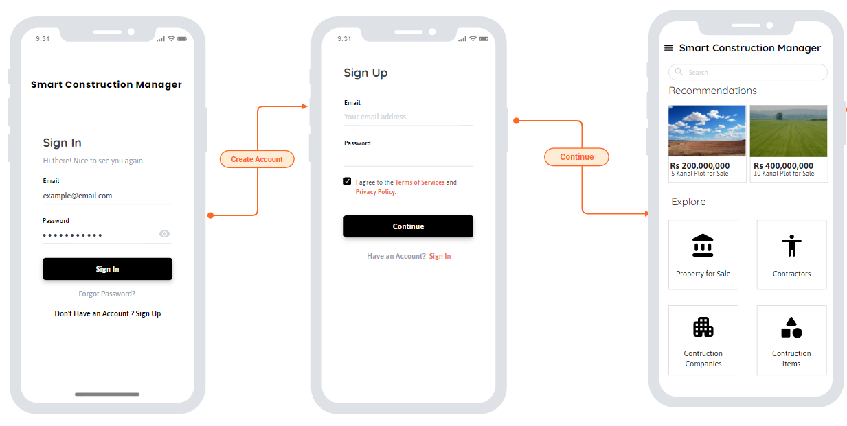

Figure 7: Mobile Home

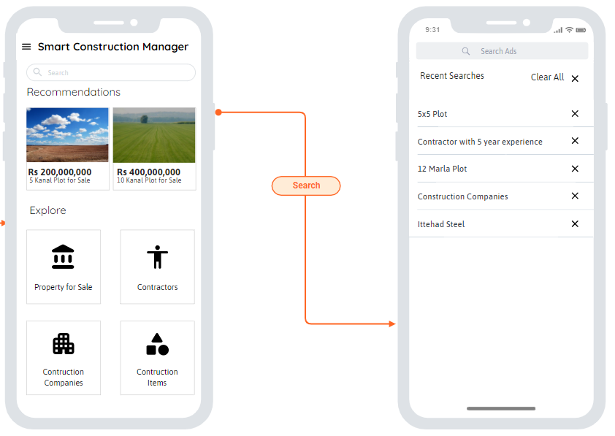

Figure 8: Mobile Search

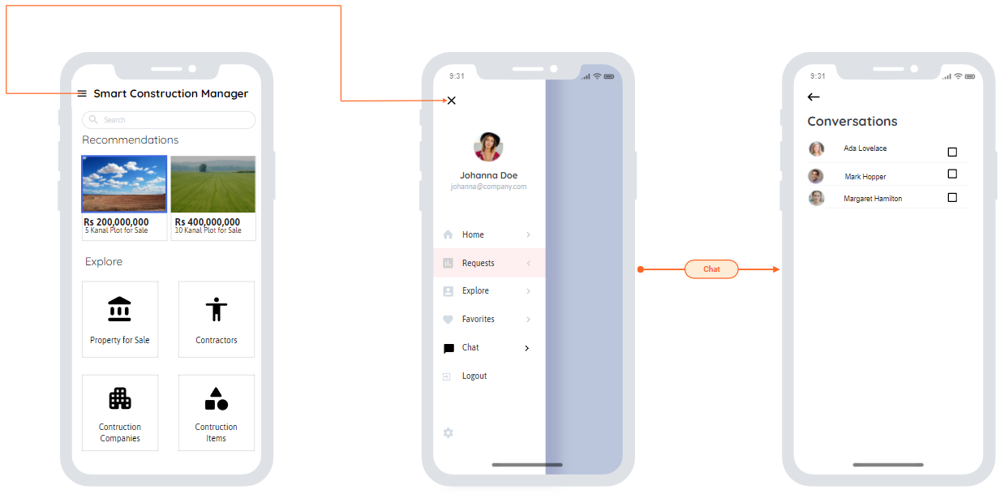

Figure 9: Mobile Chat

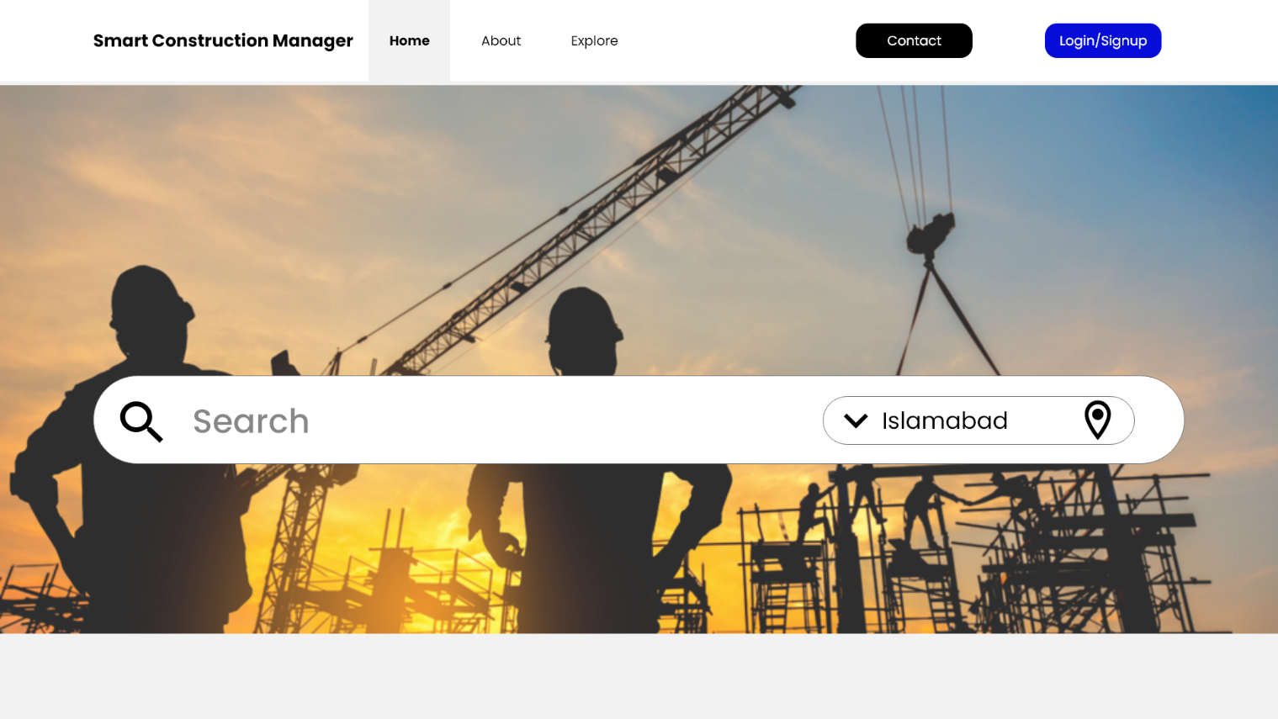

Figure 10: Web Home Interface

## Software Interfaces

The application uses MongoDB Database Management System to store public posts.

The application uses React JS for front end designing in web.

The application uses Express JS for back end development.

The application uses React Native for Mobile Development.

The application stores project data in JSON format to enable easy integration with 3rd party applications.

## Hardware Interfaces

The application requires Android Mobile device with at least Android 6.0, an IOS device with minimum IOS 9 or any desktop computer capable of running a Web Browser.

## Communication Interfaces

The application requires active internet connection which can be achieved in several ways. The application user must have working email or phone number in order to fully take advantage of the application.

# Project Gantt Chart

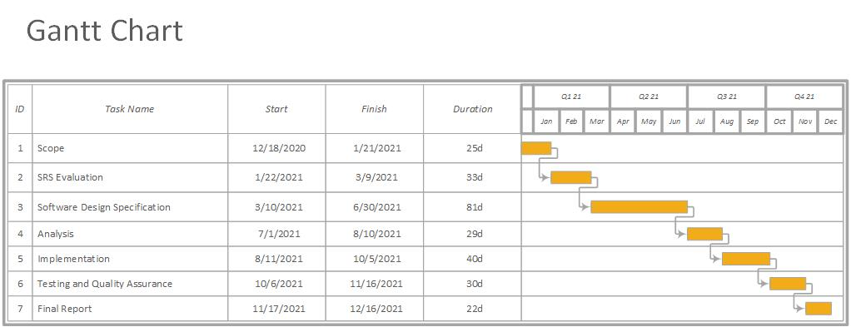

Figure 11: Gantt Chart for Targeted Project

# Conclusion

Smart Construction Manager garners the needs and requirements in each and every detail in the SRS document. Each Requirement Mentioned in the form of use cases is carefully analyzed from both Patron & Clients Perspective. The careful analysis of requirements provides Users with a sophisticated system ensuring ease in the process of construction and other commodities and forming invariably an efficient system. So, the document shows how we are planning to take our project in coming year. We will be implementing each part of our project according to the Gantt chart mentioned above and are fully motivated to complete the project.

# Appendices

SCM: Smart Construction Manager.

# References

* 1. CDA, Procedures (SOPs), https://www.cda.gov.pk/resource_center/procedures.asp#proc8, 3/7/2021**. (web site)**

# Plagiarism Report

